Domain and Range – Quadratic Functions

Graph and determine the domain and range.
1. y = –$x^{2}$ + 2 2. y = $x^{2}$ – 6x + 3 3. y = –2$x^{2}$ – 8x – 5
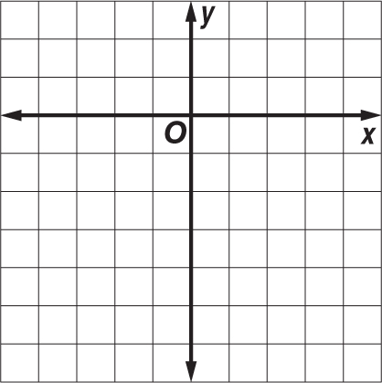
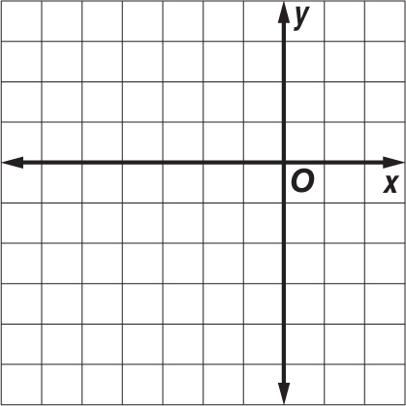
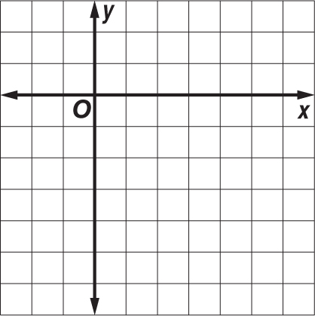

Find the domain and range of each.
4. y = $x^{2}$– 9 5. y = –2$x^{2}$ + 8x – 5 6. y = 4$x^{2}$ – 4x + 1

Consider each equation. Determine whether the function has a maximum or a minimum value. State the maximum or minimum value. What are the domain and range of the function?
7. y = 5$x^{2}$ – 2x + 2 8. y = –$x^{2}$ + 5x – 10 9. y = $\frac{3}{2}x^{2}$ + 4x – 9

Graph each function.
10. f(x) = –$x^{2}$ + 1 11. f(x) = –2$x^{2}$ + 8x – 3 12. f(x) = 2$x^{2}$ + 8x + 1
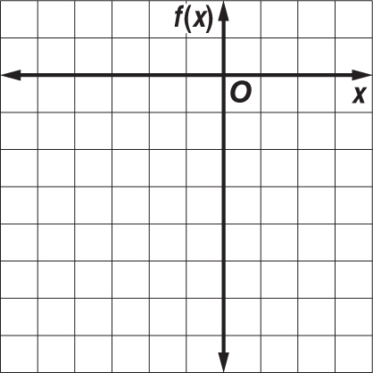
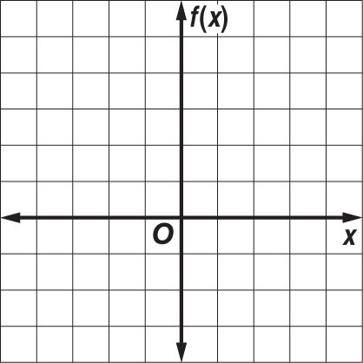
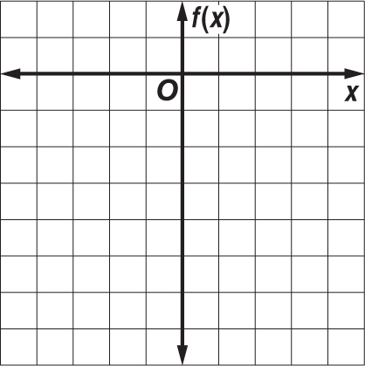

13. BASEBALL The equation h = –0.005$x^{2}$ + x + 3 describes the path of a baseball hit into the outfield, where h is the height and x is the horizontal distance the ball travels.
a. What is the maximum height reached by the baseball?
c. An outfielder catches the ball three feet above the ground. How far has the ball traveled horizontally when the outfielder catches it?

