**Trapezoids and Kites Practice**

**Find each measure.**

**1.** *m*∠*T* **2.** *m*∠*Y*

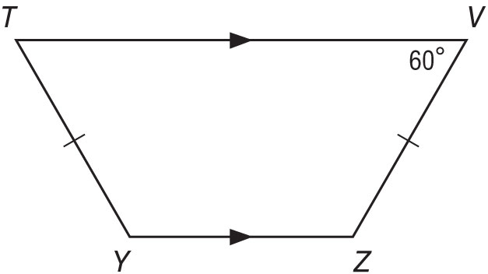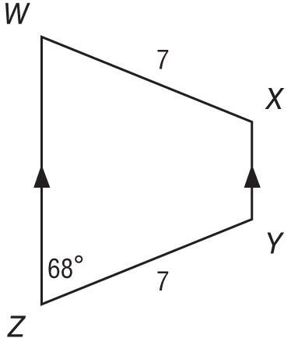

**3.** *m*∠*Q* **4.** *BC*

*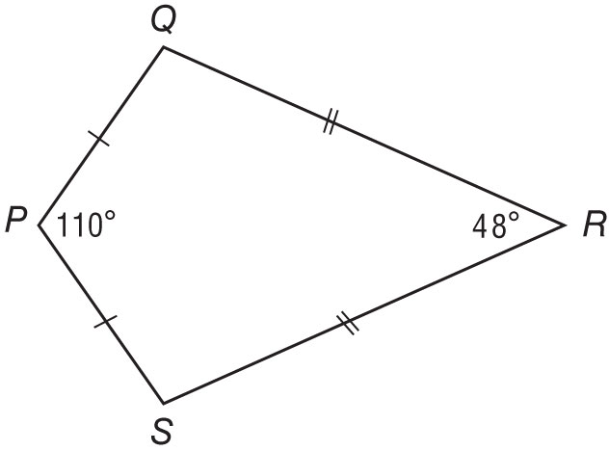*

*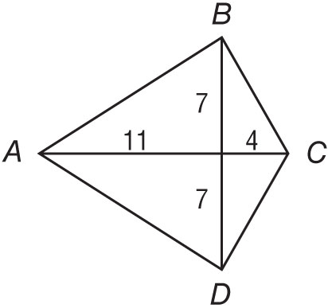*

**ALGEBRA For trapezoid *FEDC*, *V* and *Y* are midpoints of the legs.**

**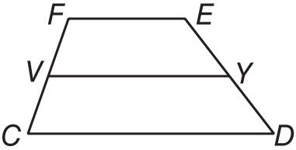**

**5.** If *FE* = 18 and *VY* = 28, find *CD*.

**6.** If *m*∠*F* = 140 and *m*∠*E* = 125, find *m*∠*D*.

**COORDINATE GEOMETRY *RSTU* is a quadrilateral with vertices *R*(–3, –3), *S*(5, 1), *T*(10, –2), *U*(–4, –9).**

**7.** Verify that *RSTU* is a trapezoid.

**8.** Determine whether *RSTU* is an isosceles trapezoid. Explain.

**9. CONSTRUCTION** A set of stairs leading to the entrance of a building is designed in the shape of an isosceles trapezoid with the longer base at the bottom of the stairs and the shorter base at the top. If the bottom of the stairs   
is 21 feet wide and the top is 14 feet wide, find the width of the stairs halfway to the top.



**10. PERSPECTIVE** Artists use different techniques to make things appear to be 3-dimensional

when drawing in two dimensions. Kevin drew the walls of a room. In real life, all of the

walls are rectangles. In what shape did he draw the side walls to make them appear

three-dimensional?

**11. AIRPORTS** A simplified drawing of the reef runway complex at Honolulu International Airport is shown below.

GEO_CH06-41_02.jpg How many trapezoids are there in this image?

**12. PLAZA** In order to give the feeling of spaciousness, an architect decides to make a plaza in the shape of a kite. Three of the four corners of the plaza are shown on the coordinate plane. If the fourth corner is in the first quadrant, what are its coordinates?

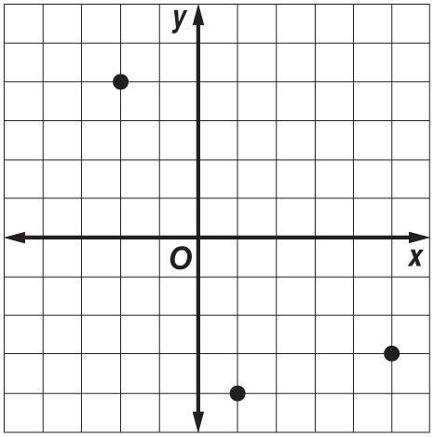

**13. RISERS** A riser is designed to elevate a speaker. The riser consists of 4 trapezoidal sections that can be stacked one on top of the other to produce trapezoids of varying heights.

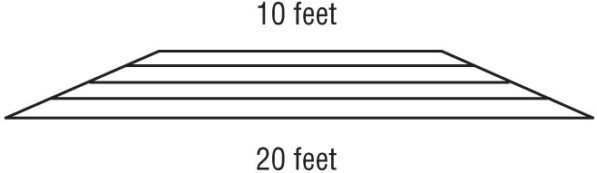

All of the stages have the same height. If all four stages are used, the width of the top of the riser is 10 feet.

**a.** If only the bottom two stages are used, what is the width of the top of the resulting riser?

**b.** What would be the width of the riser if the bottom three stages are used?

**Determine whether each statement is *sometimes, always,* or *never* true. Explain.**

**14.** The opposite angles of a trapezoid are supplementary.

**15.** In a kite, one pair of opposite sides are parallel.

**16.** A square is a rhombus.

**17.** A rectangle is a square.

**18.** A parallelogram is a rectangle.

**19.** DONE is an isosceles trapezoid, m∠EDO = 110° and m∠DEN = (15x – 5)°. Find the value of ‘x’.

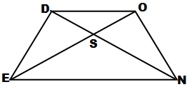

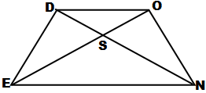

**20.** TRAP is an isosceles trapezoid, PR = 3x – 7 and TA = 20. Find the value of ‘x’.

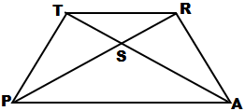

## In trapezoid ABCD, segment EF is a median. Find each of the following.

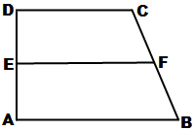

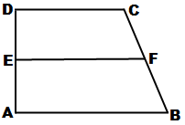

## 20. AB = 25, DC = 13, EF = \_\_\_\_\_\_\_

**21.** AE = 11, FB = 8, AD = \_\_\_\_\_\_\_, BC = \_\_\_\_\_\_\_

**22.** AB = 29, EF = 24, DC = \_\_\_\_\_\_\_

**23.** AB = 7y + 6, EF = 5y – 3, DC = y – 2, y = \_\_\_\_\_\_\_

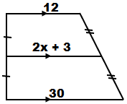

**24.** Find the value of ‘x’ for the trapezoid.

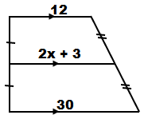

**25.** ABCD is an isosceles trapezoid. Decide whether each statement is TRUE or FALSE.

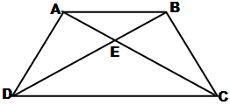

**a.** AC = BD

**b.** Segments CA and BD bisect each other