Skills Practice
Areas of Circles and Sectors

Find the area of each circle.
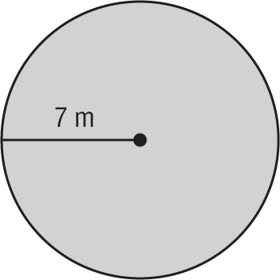
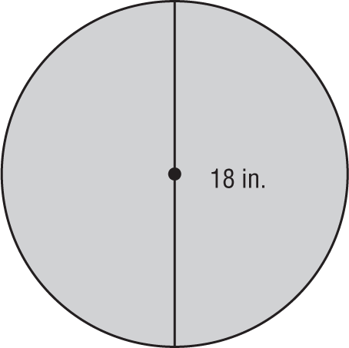
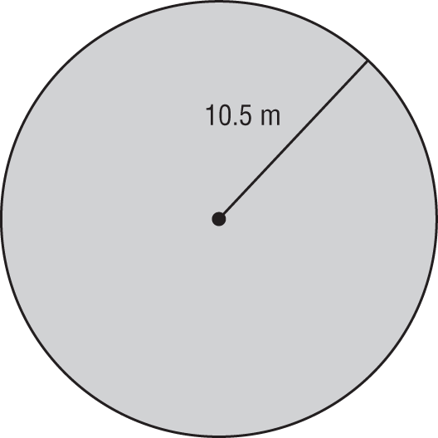
1. 2. 3.

Find the indicated measure. Round to the nearest tenth.
4. The area of a circle is 132.7 square centimeters. Find the diameter.

5. Find the diameter of a circle with an area of 1134.1 square millimeters.

6. The area of a circle is 706.9 square inches. Find the radius.

7. Find the radius of a circle with an area of 2827.4 square feet.

Find the area of each shaded sector. Round to the nearest tenth.
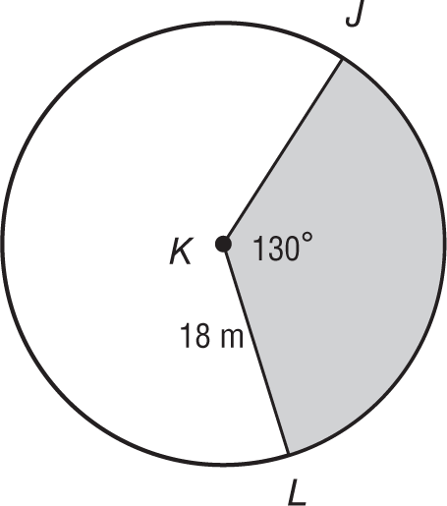
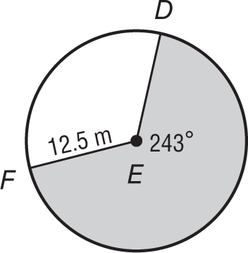
8. 9. 10.
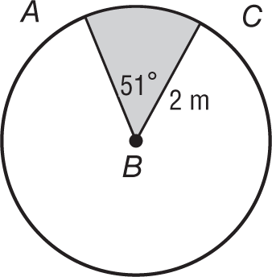

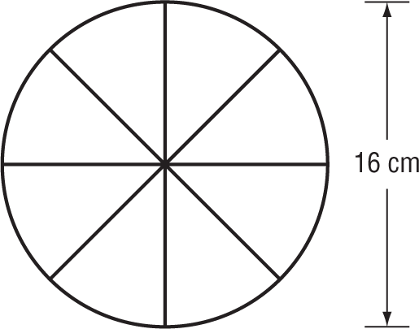
11. GAMES Jason wants to make a spinner for a new board game he invented. The spinner is a circle divided into 8 congruent pieces, what is the area of each piece to the nearest tenth?

