Study Guide and Homework
Areas of Circles and Sectors

Areas of Sectors A sector of a circle is a region bounded by a central angle and its intercepted arc.

Area of a Sector | If a sector of a circle has an area of A square units, a central angle measuring x°, and a radius of r units, then A = $\frac{x}{360}$ π$r^{2}$.

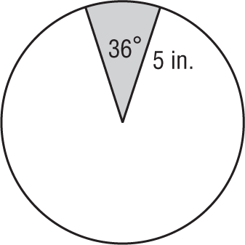
Example: Find the area of the shaded sector.
A = $\frac{x}{360}$ ⋅ π$r^{2}$ Area of a sector
= $\frac{36}{360}$ ⋅ π${(5)}^{2}$ x = 36 and r = 5
≈ 7.85 Use a calculator.
The area of the sector is about 7.85 square inches.

Exercises
Find the area of each shaded sector. Round to the nearest tenth.
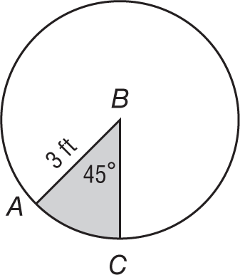
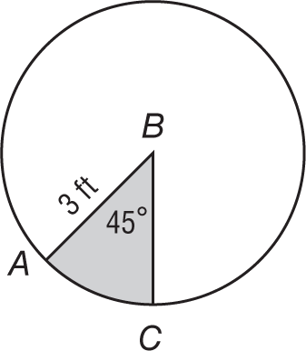
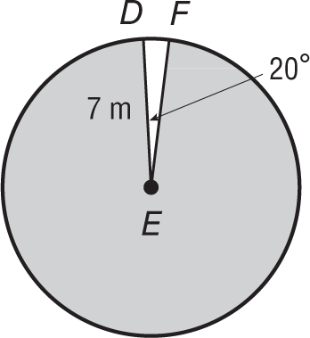
1. 2. 3.

4. 5. 6.
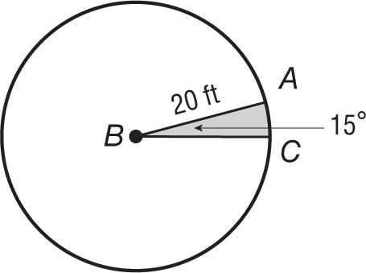
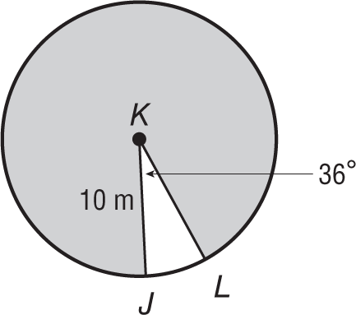
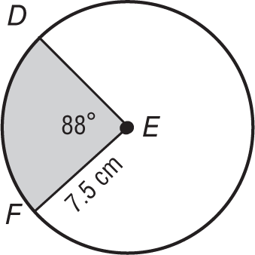

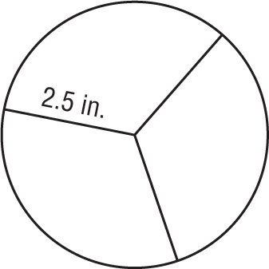
7. SANDWICHES For a party, Samantha wants to have finger sandwiches. She cuts sandwiches into circles. If she cuts each circle into three congruent pieces, what is the area of each piece?

