Skills Practice
Measuring Angles and Arcs

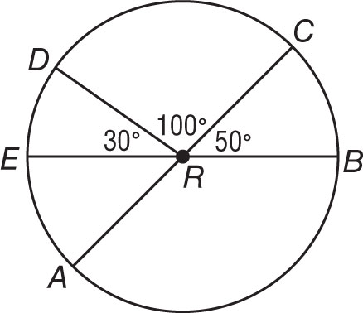
$\overline{AC}$ and $\overline{EB}$ are diameters of ⨀R. Identify each arc as a major arc, minor arc,
or semicircle of the circle. Then find its measure.

1. m$\hat{EA}$ 2. m$\hat{CB}$

3. m$\hat{DC}$ 4. m$\hat{DEB}$

5. m$\hat{AB}$ 6. m$\hat{CDA}$

$\overline{PR}$ and $\overline{QT}$ are diameters of ⨀A. Find each measure.

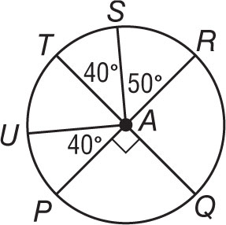
7. m$\hat{UPQ}$ 8. m$\hat{PQR}$

9. m$\hat{UTS}$ 10. m$\hat{RS}$

11. m$\hat{RSU}$ 12. m$\hat{STP}$

13. m$\hat{PQS}$ 14. m$\hat{PRU}$

Use ⨀D to find the length of each arc. Round to the nearest hundredth.
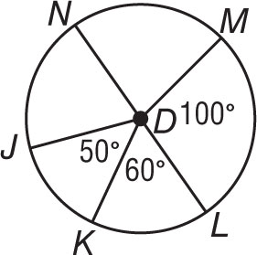
15. $\hat{LM}$ if the radius is 5 inches 16. $\hat{MN}$ if the diameter is 3 yards

17. $\hat{KL}$ if JD = 7 centimeters 18. $\hat{NJK}$ if NL = 12 feet

19. $\hat{KLM}$ if DM = 9 millimeters 20. $\hat{JK}$ if KD = 15 inches

