Practice
Measuring Angles and Arcs

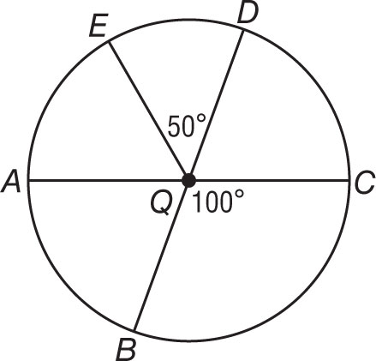
$\overline{AC}$ and $\overline{DB}$ are diameters of ⨀Q. Identify each arc as a major arc, minor arc,
or semicircle of the circle. Then find its measure.

1. m$\hat{AE}$ 2. m$\hat{AB}$

3. m$\hat{EDC}$ 4. m$\hat{ADC}$

5. m$\hat{ABC}$ 6. m$\hat{BC}$

$\overline{FH}$ and $\overline{EG}$ are diameters of ⨀P. Find each measure.
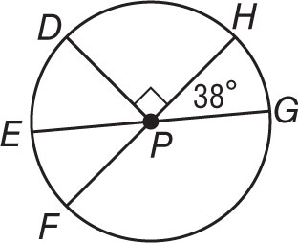
7. m$\hat{EF}$ 8. m$\hat{DE}$

9. m$\hat{FG}$ 10. m$\hat{DHG}$

11. m$\hat{DFG}$ 12. m$\hat{DGE}$

Use ⨀Z to find each arc length. Round to the nearest hundredth.
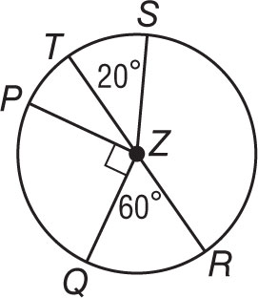
13. $\hat{QPT}$, if QZ = 10 inches 14. $\hat{QR}$, if PZ = 12 feet

15. $\hat{PQR}$, if TR = 15 meters 16. $\hat{QPS}$, if ZQ = 7 centimeters

Homework
Less than 1 hour | 8%
1–2 hours | 29%
2–3 hours | 58%
3–4 hours | 3%
Over 4 hours | 2%
17. HOMEWORK Refer to the table, which shows the number of hours students at Leland High School say they spend on homework each night.

a. If you were to construct a circle graph of the data, how many degrees would be allotted to each category?

b. Describe the arcs associated with each category.

