Name __________________________________________________ Date ______________________ Period __________

Areas of Regular Polygons
Find the area of each regular polygon. Round to the nearest tenth.
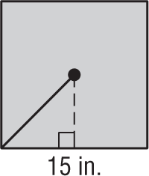
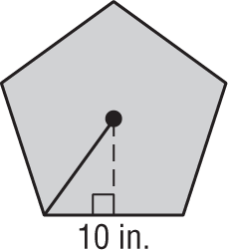
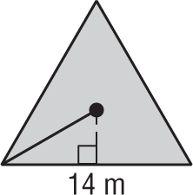
1. 2. 3.

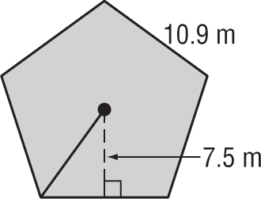
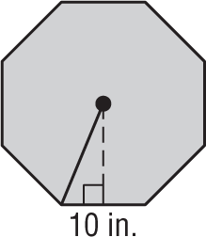
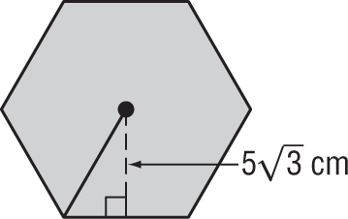
4. 5. 6.

Name __________________________________________________ Date ______________________ Period __________

Areas of Regular Polygons
Find the area of each regular polygon. Round to the nearest tenth.
1. 2. 3.

4. 5. 6.

