11-4 Study Guide and Intervention
Composite Figures

Areas of Composite Figures A composite figure is a figure that can be separated into regions that are basic figures.
To find the area of a composite figure, separate the figure into basic figures of which we can find the area. The sum of
the areas of the basic figures is the area of the figure.

Example: Find the area of the shaded region.

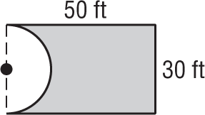
a.

The figure is a rectangle minus one half of
a circle. The radius of the circle is one half of 30 or 15.
A = lw – $\frac{1}{2}$π$r^{2}$
= 50(30) – 0.5π${(15)}^{2}$
≈ 1146.6 or about 1147 f$t^{2}$
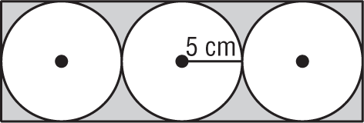
b.

The dimensions of the rectangle are
10 centimeters and 30 centimeters. The area of the shaded region is
(10)(30) – 3π(52) = 300 – 75π
≈ 64.4 ${cm}^{2}$

Exercises
Find the area of each figure. Round to the nearest tenth if necessary.
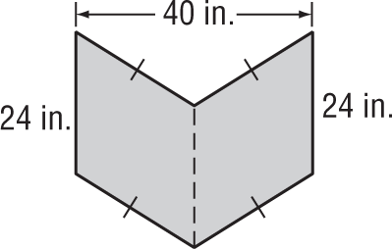
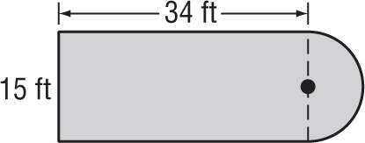
1. 2.

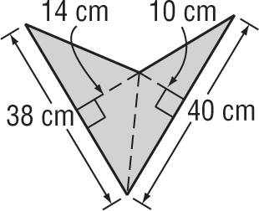
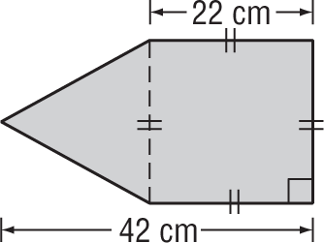
3. 4.

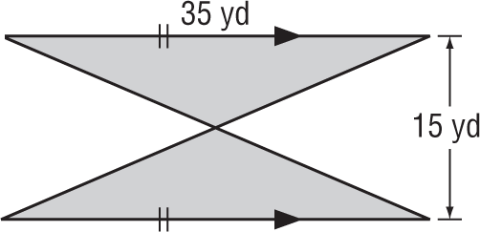
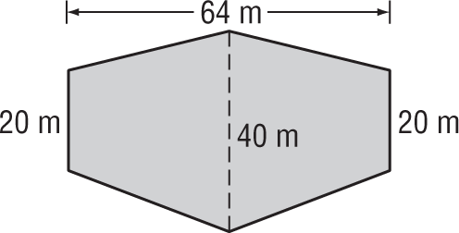
5. 6.

