11-4 Skills Practice and Practice
Composite Figures

Find the area of each figure. Round to the nearest tenth if necessary.
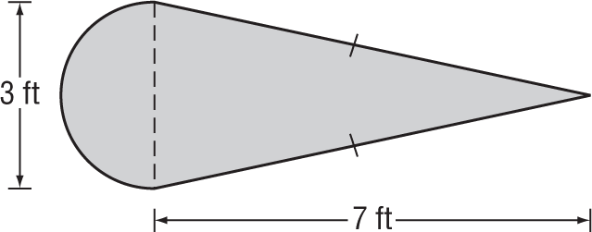
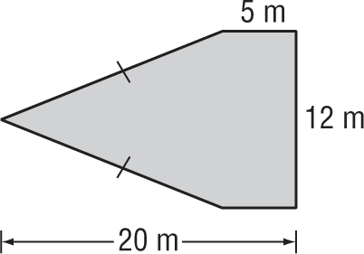
1. 2.

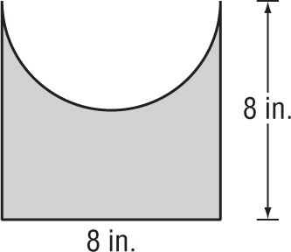
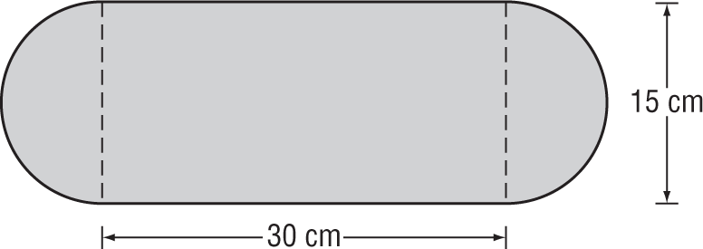
3. 4.

5. 6.
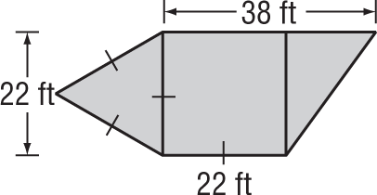
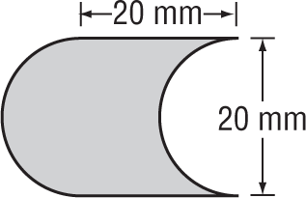

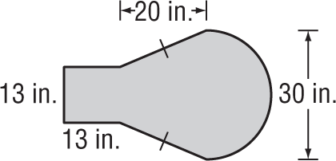
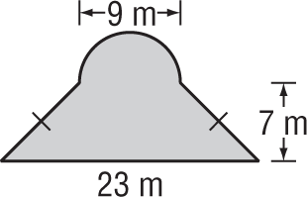
7. 8.

7. LANDSCAPING One of the displays at a botanical garden is a koi pond with a walkway around it.
The figure shows the dimensions of the pond and the walkway.

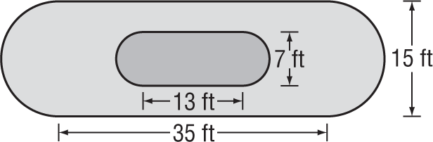

a. Find the area of the pond to the nearest tenth.

b. Find the area of the walkway to the nearest tenth.

