**Geometric Probability**

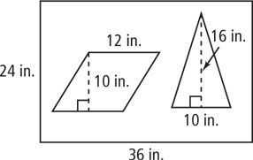If a dart lands at random on the poster at the right, what is the probability that the dart will land inside one the polygons?

Find the sum of the areas of the polygons.

area of polygons = area of parallelogram + area of triangle



= 120 + 80

= 200 in.2

Find the total area of the poster.

*A* = (24)(36) = 864 in.2

Calculate the probability.

P(polygon) = 

= 

