**Areas of Similar Figures**

**Areas of Similar Figures** If two polygons are similar, then their areas are proportional to the square of the scale factor between them.

**Example: △*JKL* ∽ △*PQR*. The area of △*JKL* is 40 square inches. Find the area of △*PQR*.**

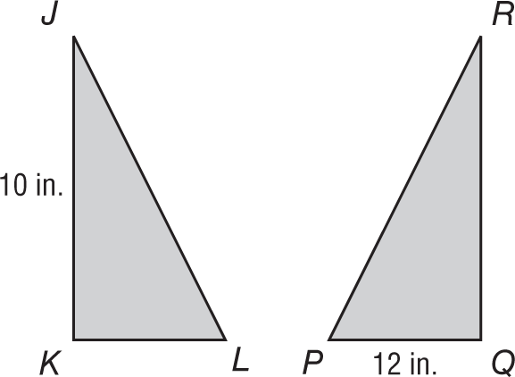Find the scale factor: or .

The ratio of their areas is .

A = 40 in2

12 in.

− = Write a proportion.

= Area of △*JKL* = 40; =

area of △*PQR* = ⋅ 40 Multiply each side by 40.

area of △*PQR* = 57.6 Simplify.

So the area of △*PQR* is 57.6 square inches.

**Exercises**

**For each pair of similar figures, find the area of the shaded figure. Round to the nearest tenth if necessary.**

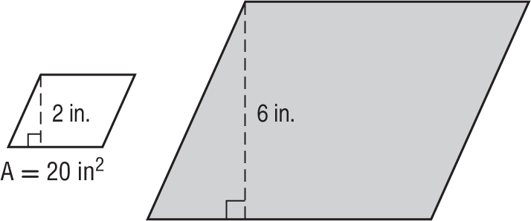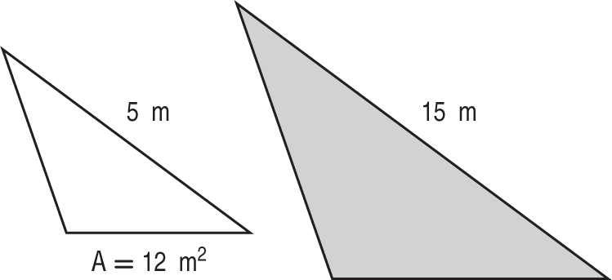 **1. 2.**

**3. 4.**

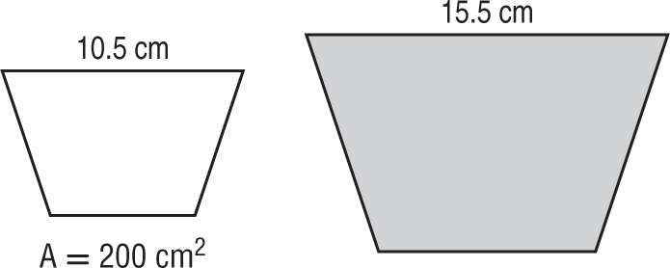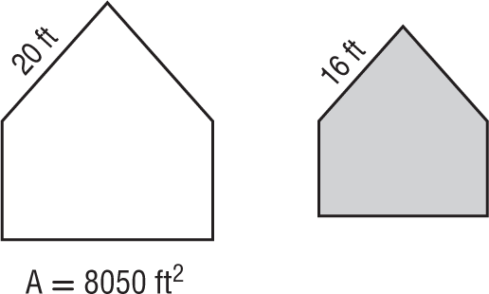**Areas of Similar Figures** *(continued)*

**PINS** Carla has a shirt with decorative pins in the shape of equilateral triangles. The pins come in two sizes. The larger pin has a side length that is three times longer than the smaller pin. If the area of the smaller pin is 6.9 square centimeters, what is the approximate area of the larger pin?

**5. 6.**



**Scale Factors and Missing Measures in Similar Figures** You can use the areas of similar figures to find the scale factor between them or a missing measure.

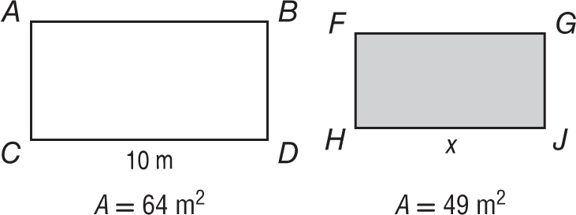**Example: If 10-s.gif*ABDC* is similar to 10-s.gif*FGJH*, find the value of *x*.**

Let *k* be the scale factor between 10-s.gif*ABDC* and 10-s.gif*FGJH*.

= Theorem 11.1

= Substitution

= *k* Take the positive square root of each side.

Use this scale factor to find the value of *x*.

= *k* The ratio of corresponding lengths of similar polygons is equal to the scale factor between the polygons.

= Substitution

*x* = ⋅ 10 or 8.75 Multiply each side by 10.

**Exercises**

**For each pair of similar figures, use the given areas to find the scale factor (in fraction form) from the unshaded to the shaded figure. Then find *x*, to the nearest tenth.**

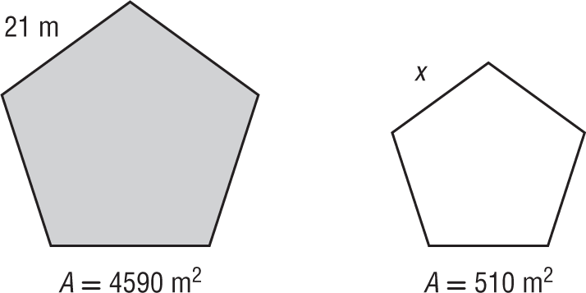**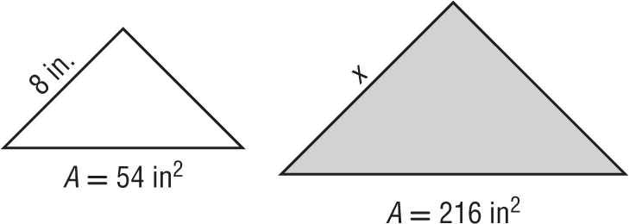 1. 2.**

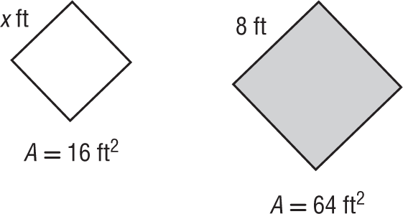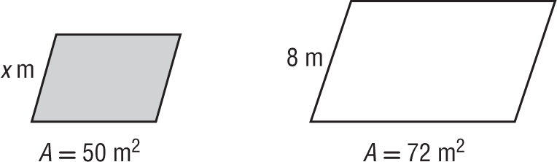 **3. 4.**



**5. ARCHERY** A target consists of two concentric similar octagons. The outside octagon has a side length of 2 feet and an area of 19.28 square feet. If the inside octagon has a side length of 1.5 feet, what is the area of the inside octagon?