Lateral and Surface Area Formulas – Prisms & Cylinders
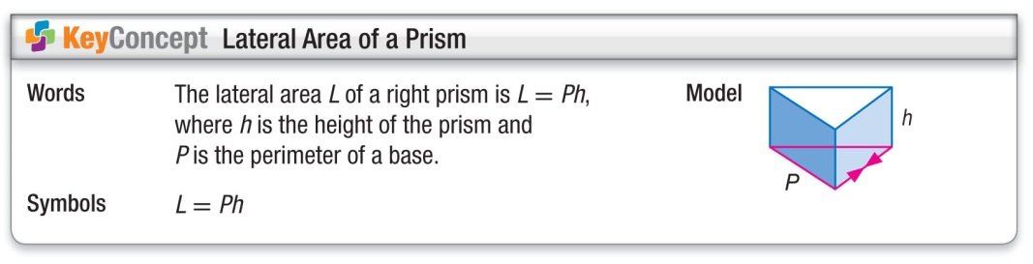
Find the lateral area of the regular hexagonal prism below.
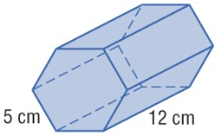
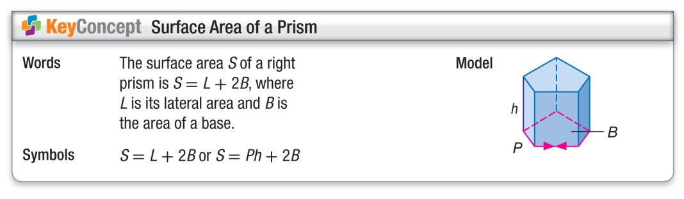
Find the surface area of the rectangular prism and triangular prism below.
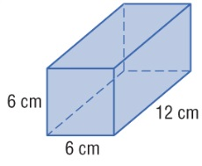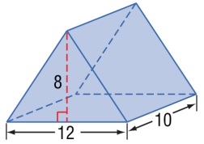
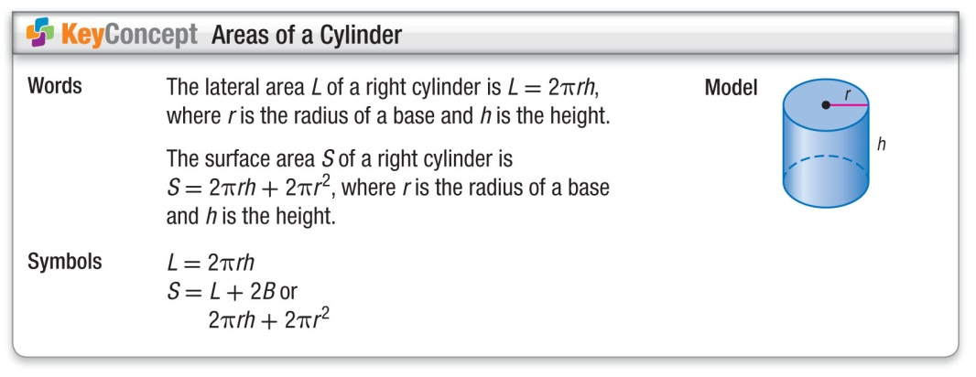
Find the lateral area and the surface area of the cylinder below. Round your answer to the nearest tenth.
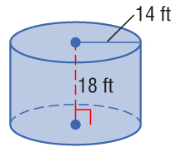

Lateral and Surface Area Formulas – Prisms & Cylinders
Find the lateral area of the regular hexagonal prism below.
Find the surface area of the rectangular prism and triangular prism below.
Find the lateral area and the surface area of the cylinder below. Round your answer to the nearest tenth.

