**12-2 Skills Practice**

***Surface Areas of Prisms and Cylinders***

**Find the lateral area and surface area of each prism. Round to the nearest tenth if necessary.**

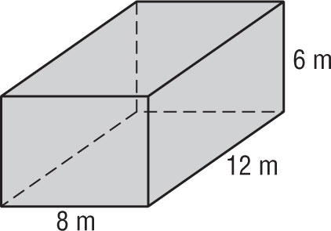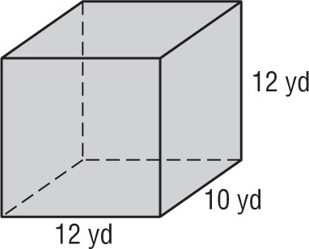 **1. 2.**

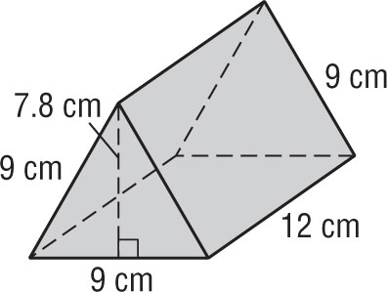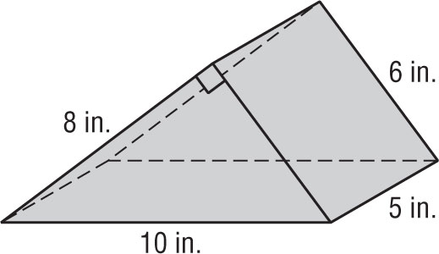 **3. 4.**

**Find the lateral area and surface area of each cylinder. Round to the nearest tenth.**

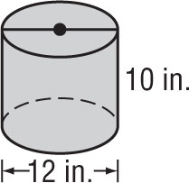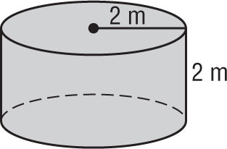 **5. 6.**

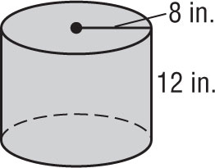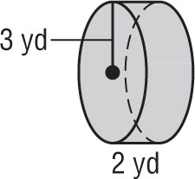 **7. 8.**