12-2 Word Problem Practice
Surface Areas of Prisms and Cylinders

1. LOGOS The Z company specializes in caring for zebras. They want to make a 3-dimensional “Z” to put in front of their company headquarters. The “Z” is 15 inches thick and the perimeter of the base is 390 inches.

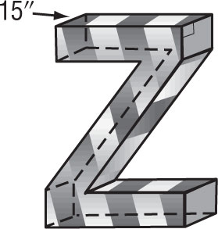

What is the lateral surface area of this “Z”?

2. STAIRWELLS Management decides to enclose stairs connecting the first and second floors of a parking garage in a stairwell shaped like an oblique rectangular prism.

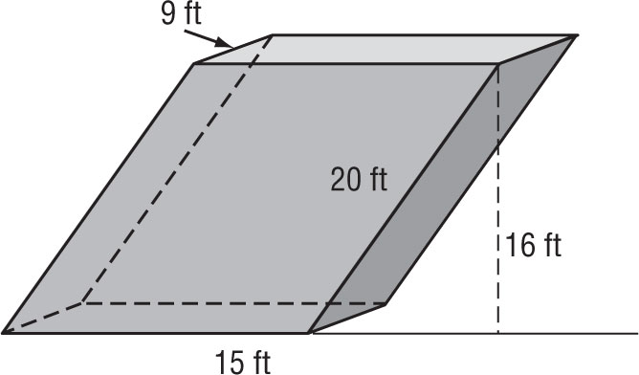

What is the lateral surface area of the stairwell?

3. CAKES A cake is a rectangular prism with height
4 inches and base 12 inches by 15 inches. Wallace wants to apply frosting to the sides and the top of the cake. What is the surface area of the part of the cake that will have frosting?
4. EXHAUST PIPES An exhaust pipe is shaped like a cylinder with a height of 50 inches and a radius of 2 inches. What is the lateral surface area of the exhaust pipe? Round your answer to the nearest hundredth.

5. TOWERS A circular tower is made by placing one cylinder on top of another. Both cylinders have a height of 18 inches. The top cylinder has a radius of 18 inches and the bottom cylinder has a radius of
36 inches.

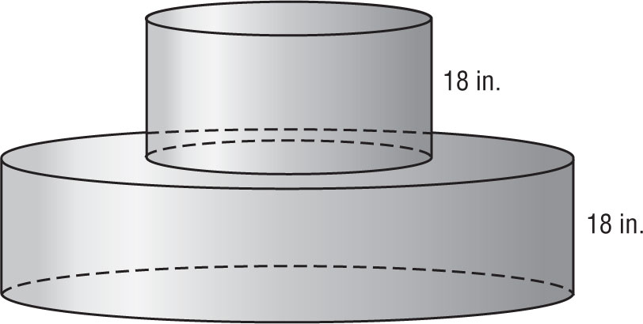

a. What is the total surface area of the tower?
Round your answer to the nearest hundredth.

b. Another tower is constructed by placing the original tower on top of another cylinder with a height of 18 inches and a radius of 54 inches.
What is the total surface area of the new tower? Round your answer to the nearest hundredth.

