Lateral and Surface Area Formulas – Pyramids
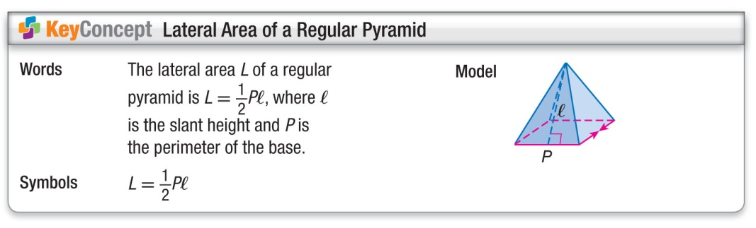
Find the lateral area of the square pyramids.
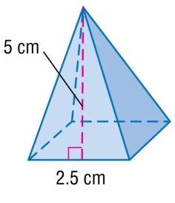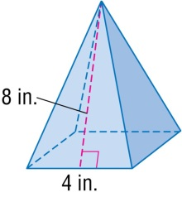
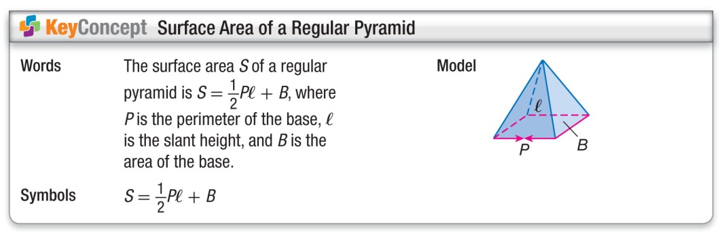
Find the surface area of the square pyramid to the nearest tenth.
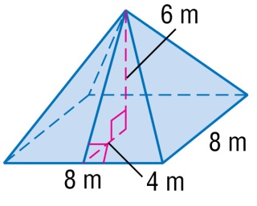
Find the surface area of the regular pyramid. Round to the nearest tenth.
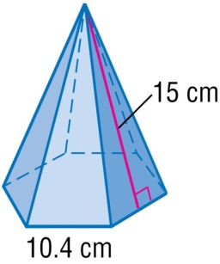
Lateral and Surface Area Formulas – Pyramids
Find the lateral area of the square pyramids.
Find the surface area of the square pyramid to the nearest tenth.
Find the surface area of the regular pyramid. Round to the nearest tenth.

