Lateral and Surface Area Formulas – Cones and Spheres
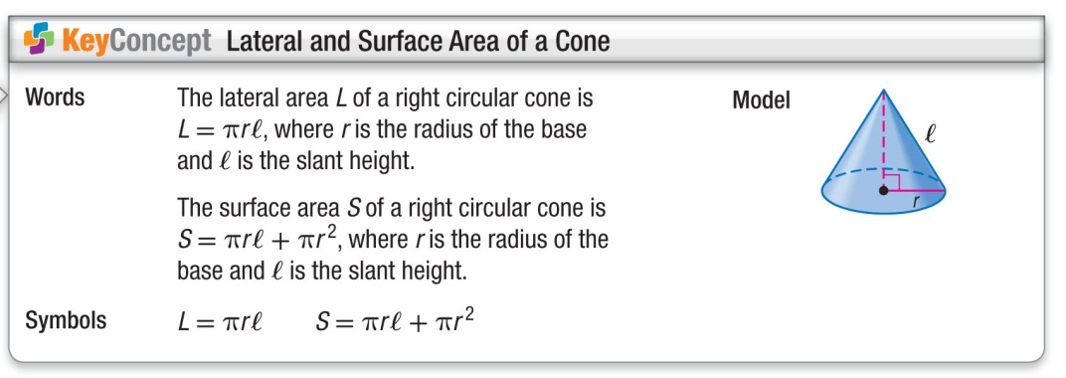
Find the lateral area and surface area of each cone to the nearest tenth.
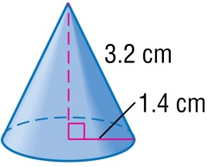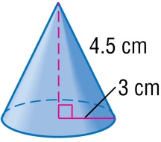

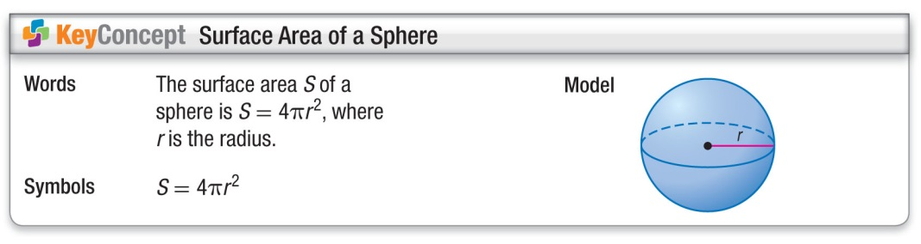
Find the surface area of each sphere. Round to the nearest tenth.
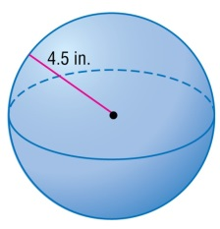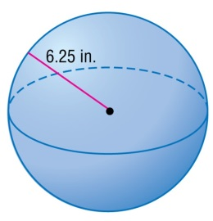
Find the surface area of the hemisphere.
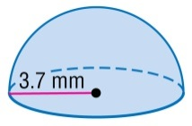
Lateral and Surface Area Formulas – Cones and Spheres
Find the lateral area and surface area of each cone to the nearest tenth.

Find the surface area of each sphere. Round to the nearest tenth.
Find the surface area of the hemisphere.

