12-3 Skills Practice
Surface Areas of Pyramids and Cones

Find the lateral area and surface area of each regular pyramid. Round to the nearest tenth if necessary.

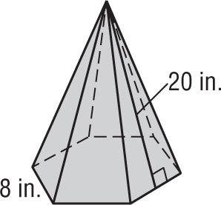
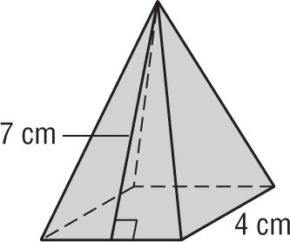
1. 2.

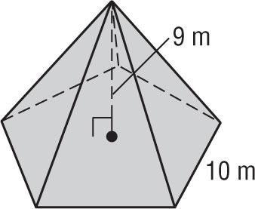
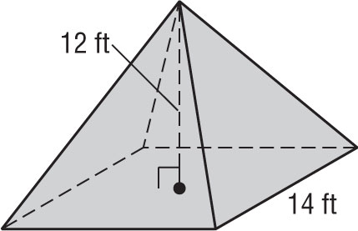
3. 4.

Find the lateral area and surface area of each cone. Round to the nearest tenth.

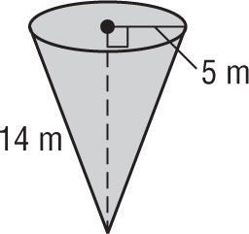
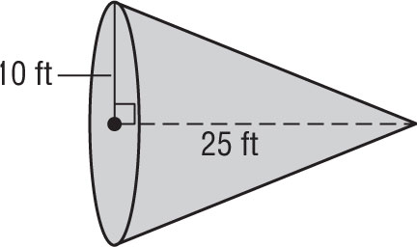
5. 6.

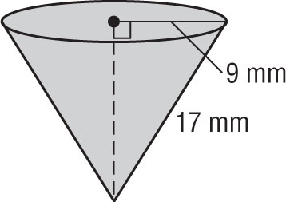
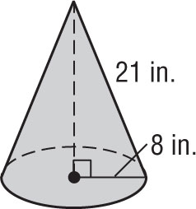
7. 8.

Surface Areas of Spheres

Find the surface area of each sphere or hemisphere. Round to the nearest tenth.
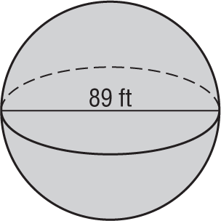
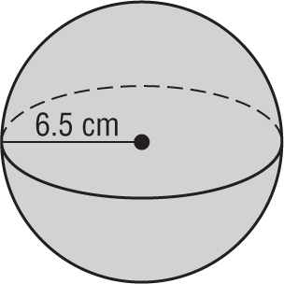
1. 2.

3. hemisphere: radius of great circle = 8.4 in.

4. sphere: area of great circle ≈ 29.8 $m^{2}$

Find the area of each sphere or hemisphere. Round to the nearest tenth.
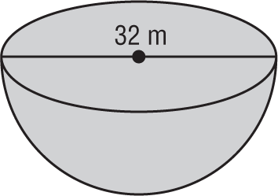
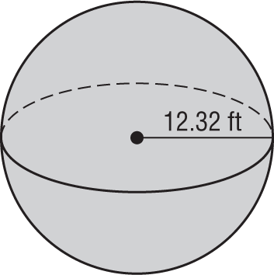
5. 6.

7. hemisphere: diameter = 18 mm

8. sphere: circumference ≈ 36 yd

9. sphere: radius = 12.4 in.

