12-3 Practice
Surface Areas of Pyramids and Cones

Find the lateral area and surface area of each regular pyramid. Round to the nearest tenth if necessary.

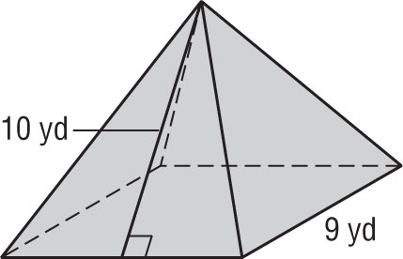
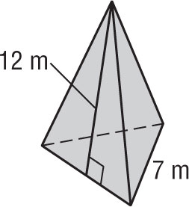
1. 2.

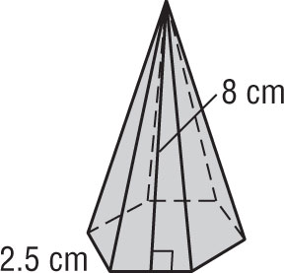
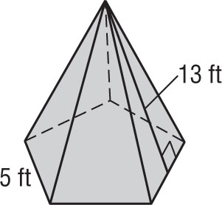
3. 4.

Find the lateral area and surface area of each cone. Round to the nearest tenth if necessary.

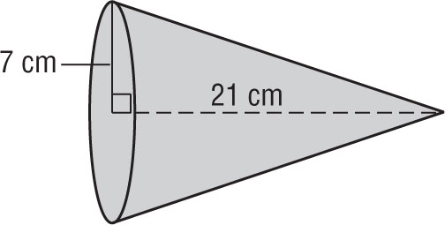
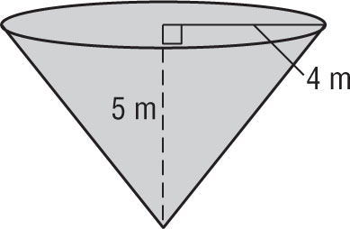
5. 6.

7. Find the surface area of a cone if the height is 14 centimeters and the slant height is 16.4 centimeters.

8. Find the surface area of a cone if the height is 12 inches and the diameter is 27 inches.

9. GAZEBOS The roof of a gazebo is a regular octagonal pyramid. If the base of the pyramid has sides of 0.5 meter and the slant height of the roof is 1.9 meters, find the area of the roof.

10. HATS Cuong bought a conical hat on a recent trip to central Vietnam. The basic frame of the hat is 16 hoops of bamboo that gradually diminish in size. The hat is covered in palm leaves. If the hat has a diameter of 50 centimeters and a slant height of 32 centimeters, what is the lateral area of the conical hat?

Exercises
Find the surface area of each sphere or hemisphere. Round to the nearest tenth.
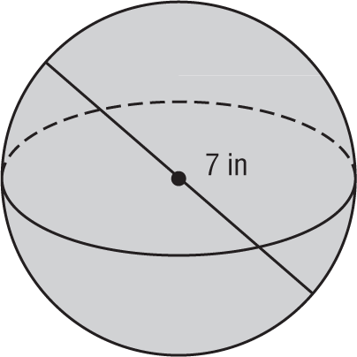
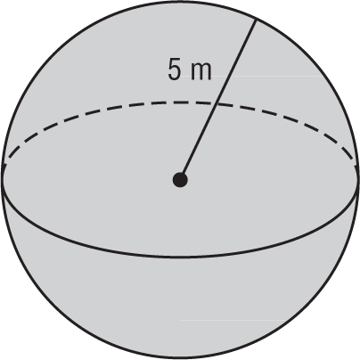
1. 2.

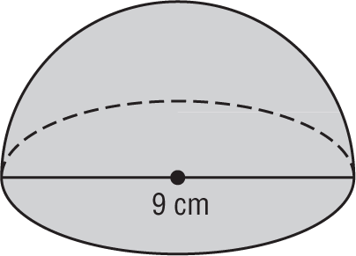
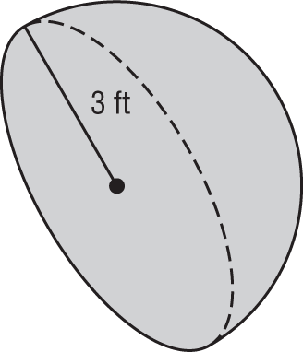
3. 4.

5. TETRAHEDRON Sung Li builds a paper model of a regular tetrahedron, a pyramid with an equilateral triangle for the base and three equilateral triangles for the lateral faces. One of the faces of the tetrahedron has an area of 17 square inches. What is the total surface area of the tetrahedron?

6. MOONS OF SATURN The planet Saturn has several moons. These can be modeled accurately by spheres. Saturn’s largest moon Titan has a radius of about 2575 kilometers. What is the approximate surface area of Titan? Round your answer to the nearest tenth.

