12-4 Study Guide and Intervention
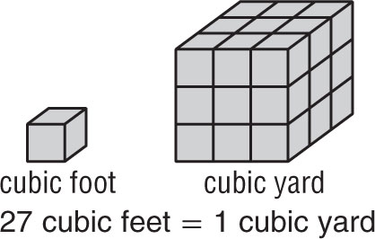
Volumes of Prisms and Cylinders

Volumes of Prisms The measure of the amount of space that a three-dimensional figure encloses is the volume of the figure. Volume is measured in units such as cubic feet, cubic yards, or cubic meters. One cubic unit is the volume of a cube that measures one unit on each edge.

Volume  of a Prism | If a prism has a volume of V cubic units, a height of h units, and each base has an area of B square units, then V = Bh.

Example 1: Find the volume of the prism.
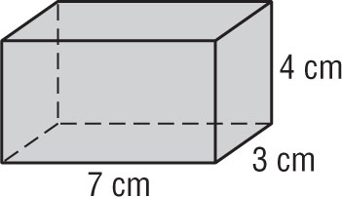

V = Bh Volume of a prism
= (7)(3)(4) B = (7)(3), h = 4
= 84 Multiply.
The volume of the prism is 84 cubic centimeters.

Example 2: Find the volume of the prism if the area of each base is 6.3 square feet.
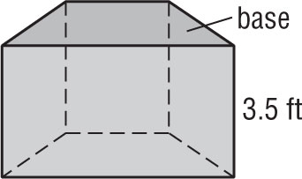

V = Bh Volume of a prism
= (6.3)(3.5) B = 6.3, h = 3.5
= 22.05 Multiply.
The volume is 22.05 cubic feet.

Exercises
Find the volume of each prism. Round to the nearest tenth.

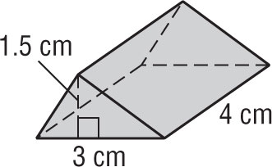
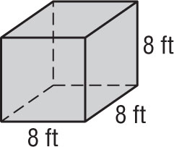
1. 2.

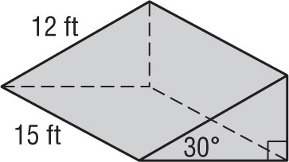
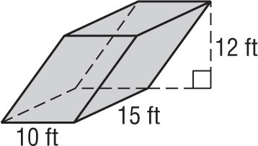
3. 4.

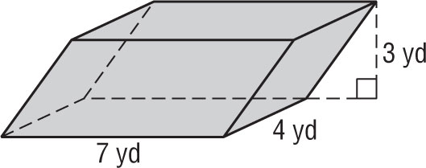
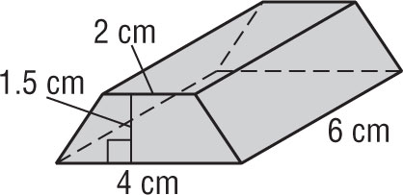
5. 6.

12-4 Study Guide and Intervention (continued)
Volumes of Prisms and Cylinders
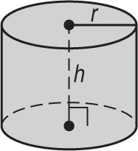
Volumes of Cylinders The volume of a cylinder is the product of the height and the area of the base. When a solid is not a right solid, use Cavalieri’s Principle to find the volume. The principle states that if two solids have the same height and the same cross sectional area at every level, then they have the same volume.

Volume of  a Cylinder | If a cylinder has a volume of V cubic units, a height of h units, and the bases have a radius of r units, then V = ${πr}^{2}$h.

Example 1: Find the volume of the cylinder.
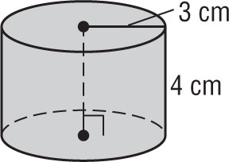

V = ${πr}^{2}$h Volume of a cylinder
= ${π(3)}^{2}$(4) r = 3, h = 4
≈ 113.1 Simplify.
The volume is about 113.1 cubic centimeters.

Example 2: Find the volume of the oblique cylinder.
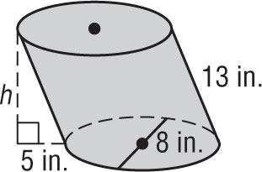

Use the Pythagorean Theorem to find the height of the cylinder.
$h^{2}$ + $5^{2}$ = ${13}^{2}$ Pythagorean Theorem
$h^{2}$ = 144 Simplify.
h = 12 Take the positive square root of each side.
V = ${πr}^{2}$h Volume of a cylinder
= ${π(4)}^{2}$(12) r = 4, h = 12
≈ 603.2 Simplify.
The Volume is about 603.2 cubic inches.

Exercises
Find the volume of each cylinder. Round to the nearest tenth.

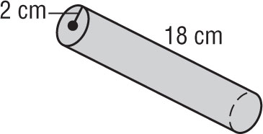
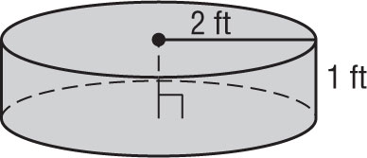
1. 2.

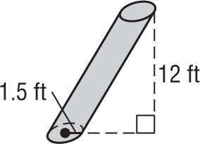
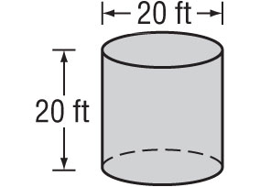
3. 4.

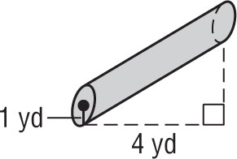
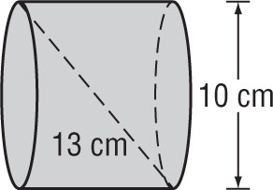
5. 6.

