CAVALIERI’S PRINCIPLE

Suppose you have a right rectangular prism and divide it horizontally into thin rectangular slices. The base of each rectangular slice, or cross section, has the same area as the base of the prism. If you rearrange the slices, the total volume of the slices does not change.
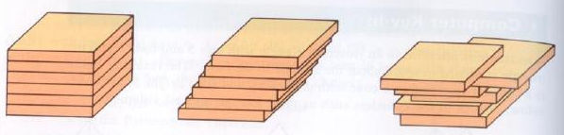
Cavalieri’s Principle – If two solids lying between parallel planes have equal heights and all cross sections at equal distances from their bases have equal areas, then the solids have equal volumes.
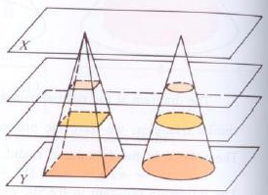
Cavalieri’s Principle can be applied to more complicated shapes, such as when the width of a prism becomes smaller and smaller. This principle led to what is now known as integral calculus.
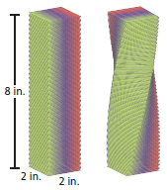
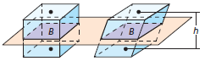
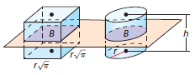
CAVALIERI’S PRINCIPLE

Suppose you have a right rectangular prism and divide it horizontally into thin rectangular slices. The base of each rectangular slice, or cross section, has the same area as the base of the prism. If you rearrange the slices, the total volume of the slices does not change.
Cavalieri’s Principle – If two solids lying between parallel planes have equal heights and all cross sections at equal distances from their bases have equal areas, then the solids have equal volumes.
Cavalieri’s Principle can be applied to more complicated shapes, such as when the width of a prism becomes smaller and smaller. This principle led to what is now known as integral calculus.

