12-4 Practice
Volumes of Prisms and Cylinders

Find the volume of each prism or cylinder. Round to the nearest tenth if necessary.
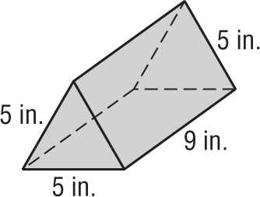
1. 2.
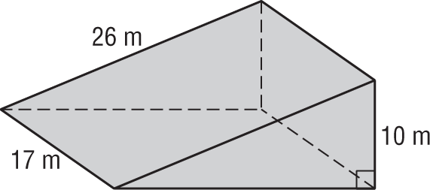

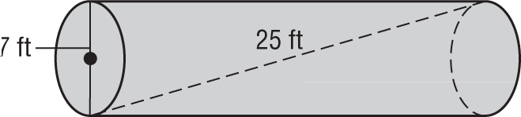
3. 4.
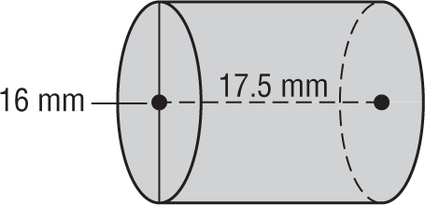

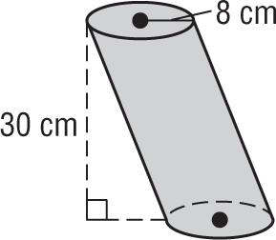
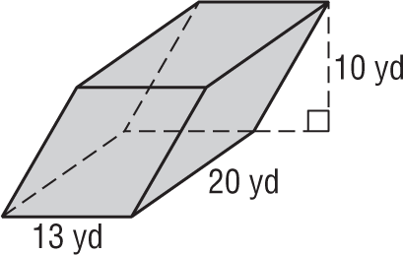
5. 6.

7. AQUARIUM Mr. Gutierrez purchased a cylindrical aquarium for his office. The aquarium has a height of 25 $\frac{1}{2}$ inches and a radius of 21 inches.

a. What is the volume of the aquarium in cubic feet?

b. If there are 7.48 gallons in a cubic foot, how many gallons of water does the aquarium hold?

c. If a cubic foot of water weighs about 62.4 pounds, what is the weight of the water in the aquarium to the "nearest five pounds?

