12-4 Word Problem Practice
Volumes of Prisms and Cylinders

1. TRASH CANS The Meyer family uses a kitchen
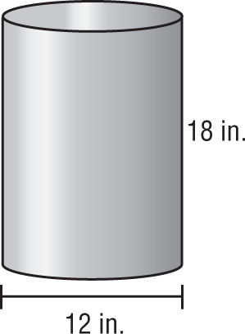
trash can shaped like a cylinder. It has a height of 18 inches and a base diameter of 12 inches. What is the volume of the trash can? Round your answer to the nearest tenth of a cubic inch.

2. BENCH Inside a lobby, there is a piece of furniture for sitting. The furniture is shaped like a simple block with a square base 6 feet on each side and a height of 1$\frac{3}{5}$ feet.

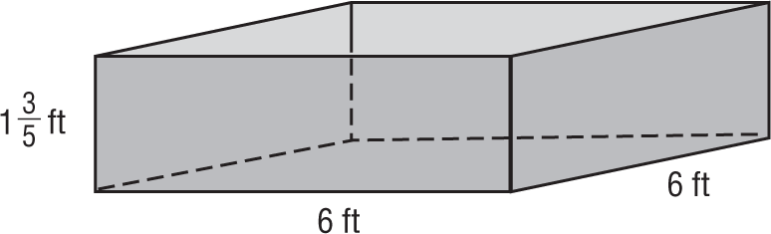

What is the volume of the seat?

3. FRAMES Margaret makes a square frame out of four
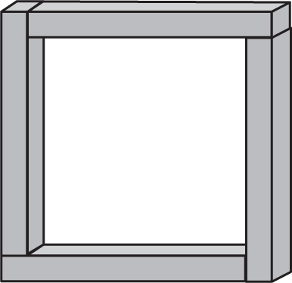
pieces of wood. Each piece of wood is a rectangular prism with a length of 40 centimeters, a height of 4 centimeters, and a depth of 6 centimeters. What is the total volume of the wood used in the frame?
4. PENCIL GRIPS A pencil grip is shaped like a triangular prism with a cylinder removed from the middle. The base of the prism is a right isosceles triangle with leg lengths of 2 centimeters. The diameter of the base of the removed cylinder is
1 centimeter. The heights of the prism and the cylinder are the same, and equal to 4 centimeters.

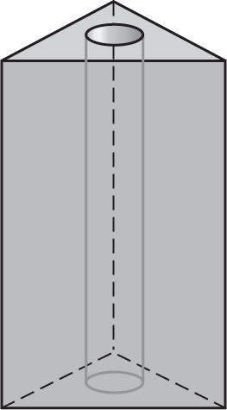

What is the exact volume of the pencil grip?

5. TUNNELS Construction workers are digging a tunnel through a mountain. The space inside the tunnel is going to be shaped like a rectangular prism. The mouth of the tunnel will be a rectangle 20 feet high and 50 feet wide and the length of the tunnel will be 900 feet.

a. What will the volume of the tunnel be?

b. If instead of a rectangular shape, the tunnel had a semicircular shape with a 50-foot diameter, what would be its volume? Round your answer to the nearest cubic foot.

