Volume Formulas – Pyramids & Cones
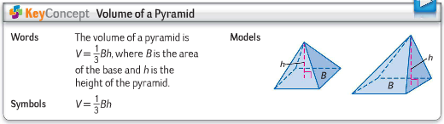

Find the volume of the SQUARE pyramids below.
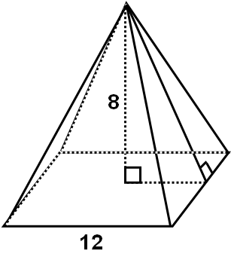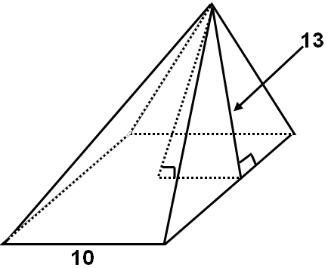

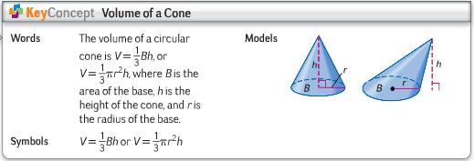
Find the exact and decimal volume of the cones below, to the nearest
hundredth.
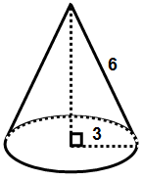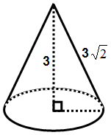
The volume of a cone is 12π ft³ and the radius is 3 ft. Find the height.

Volume Formulas – Pyramids & Cones

Find the volume of the SQUARE pyramids below.

Find the exact and decimal volume of the cones below, to the nearest
hundredth.
The volume of a cone is 12π ft³ and the radius is 3 ft. Find the height.

