12-5 Practice
Volumes of Pyramids and Cones

Find the volume of each pyramid or cone. Round to the nearest tenth if necessary.
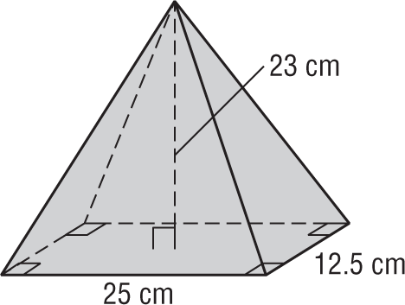
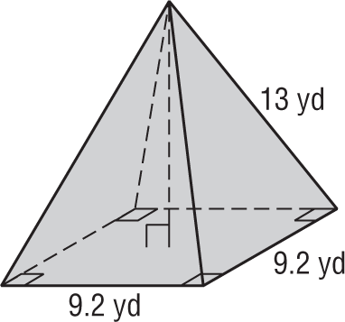
1. 2.

3. 4.
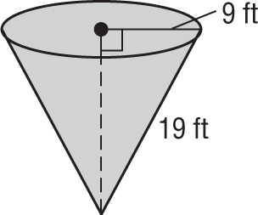
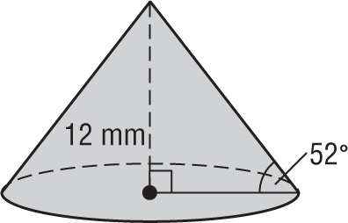

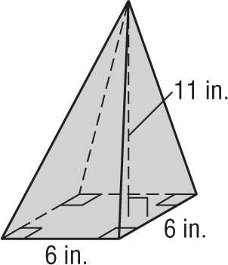
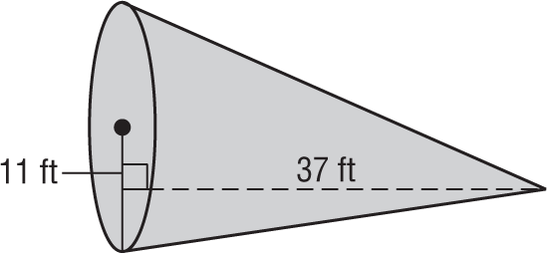
5. 6.

7. CONSTRUCTION Mr. Ganty built a conical storage shed. The base of the shed is 4 meters in diameter and the height of the shed is 3.8 meters. What is the volume of the shed?

8. HISTORY The start of the pyramid age began with King Zoser’s pyramid, erected in the 27th century B.C. In its original state, it stood 62 meters high with a rectangular base that measured 140 meters by 118 meters. Find the volume of the original pyramid.

