VOLUME OF PYRAMIDS AND CONES PRACTICE

Volume or capacity of a three dimensional figure (solid) is the amount of space it encloses. Volume is measured in cubic units (u³).

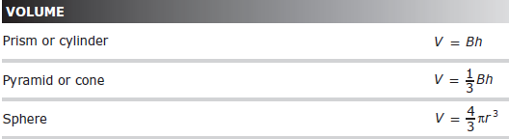

Find the volume of each right solid. Assume the bases are regular.
1. Square Pyramid 2. Cone
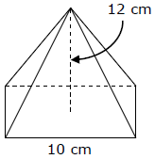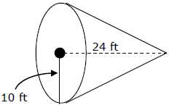

3. Hexagonal Pyramid 4. Composite of Cylinder and Cone
