Volume Formula - Sphere
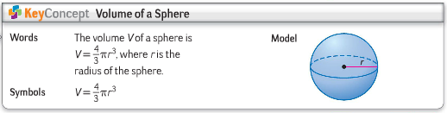
Find the exact and decimal volume of the spheres in numbers 1 through 4 below. Round your answers to the nearest hundredth.
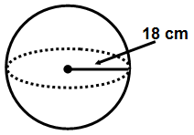
1.
2. A sphere with a diameter of 12 cm.

3. A sphere with a surface area of 12π square units.

4. A sphere with a great circle circumference of 32π feet.

5. A sphere has a volume of $\frac{4000}{3}$ cubic meters. Find the radius.

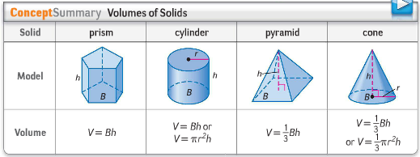

Volume Formula - Sphere
Find the exact and decimal volume of the spheres in numbers 1 through 4 below. Round your answers to the nearest hundredth.
1.
2. A sphere with a diameter of 12 cm.

3. A sphere with a surface area of 12π square units.

4. A sphere with a great circle circumference of 32π feet.

5. A sphere has a volume of $\frac{4000}{3}$ cubic meters. Find the radius.

