12-6 Skills Practice and Practice
Volumes of Spheres

Find the volume of each sphere or hemisphere. Round to the nearest tenth.
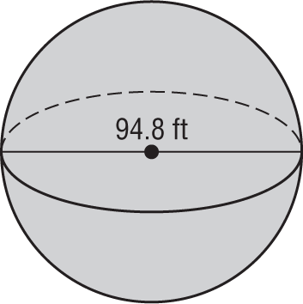
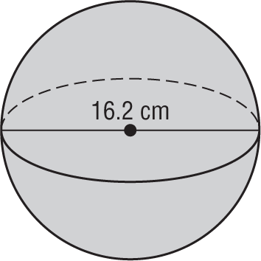
1. 2.

3. hemisphere: diameter = 48 yd

4. sphere: circumference of a great circle ≈ 26 m

5. sphere: diameter = 10 in.

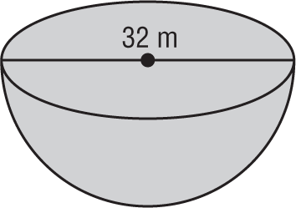
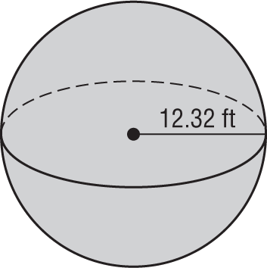
6. 7.

8. hemisphere: diameter = 18 mm

9. sphere: circumference ≈ 36 yd

10. sphere: radius = 12.4 in.

11. Find the air capacity (volume) of a basketball with a radius of 4.75 inches. Give your answer in cubic inches and
cubic centimeters. (2.54 centimeters = 1 inch)

