VOLUME OF SOLIDS PRACTICE

1. A three-dimensional figure is formed by placing a square pyramid on top of a prism as shown below. Determine an equation to represent the volume of the figure in cubic inches.
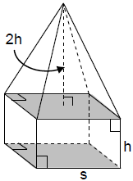

2. The Luxor Hotel in Las Vegas, Nevada, is shaped like a square pyramid whose surface is covered in dark glass. The sides of the building are 606 feet in length. The height of the building at the apex of the pyramid is 350 feet. If the entire building were to be air conditioned, how many cubic feet capacity are in the building?

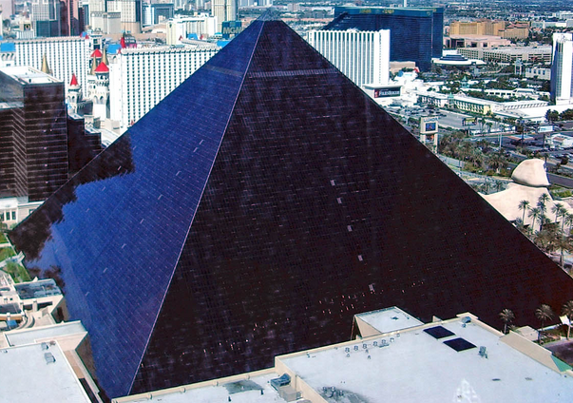

3. The three-dimensional figure below is formed by placing a cone on top of a cylinder. Determine an equation that could be used to represent the volume of the figure in cubic inches.
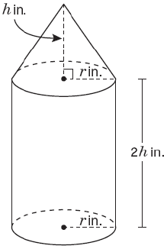
4. The drill team will be selling ice cream cones at the baseball playoff. Each cone will be 12 cm high with a diameter of 6 cm. Ice cream will be packed into the cone and also form a hemisphere above the cone. Due to health regulations, each cone must be covered in a piece of paper before served.
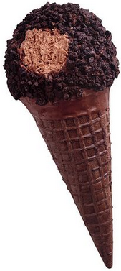
- What is the minimum amount of paper needed to cover the outside of the cone?

- What volume of ice cream will be needed to fill each cone?

- If the top ice cream dome is to be dipped in chocolate, what is the surface area of ice cream to be covered?

- If the layer of dipped chocolate averages 0.2 cm in thickness, what volume of chocolate is needed for each cone?

5. Find the air capacity of a volleyball with a circumference of 27 inches. Give your answer in cubic inches and cubic centimeters. (2.54 in = 1 cm)
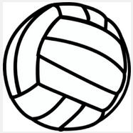
6. A model of a right pyramid has an altitude of 15 cm. If the base is a regular pentagon with sides of 5.8 cm, what is the volume of the pyramid?

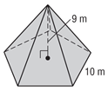
5.8 cm

15 cm

7. Find the volume of a right cone, if the slant height is 14 meters and the diameter of the base is 8 meters.
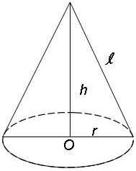

8. Orange cylindrical containers are used to set off construction sites along the road. Each container is filled with sand. If the containers have a diameter of 28 inches and a height of 4 feet, how many cubic feet of sand does each container hold, if filled to the top? How many cubic meters of sand does each container hold, if filled to the top? (3.28 ft = 1 m)

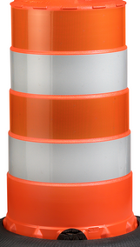
Cavalieri’s Principle: If two three-dimensional figures have the same height and the same cross-sectional area at every level, then they have the same volume.

9. Use Cavalieri’s Principal to find the volume of the following two oblique prisms.
a.
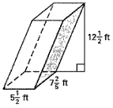

b.
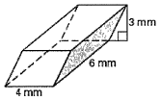

10. What is the volume of the oblique cone shown below? Give your answer in terms of $π$ and also rounded to the nearest cubic foot.

