Scale Factor

For Problems 1–3, state how each transformation affects the area.

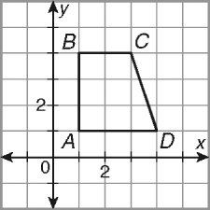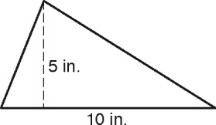 1. 2.

The base of the triangle is tripled. The height of a trapezoid with vertices

A(1, 1), B(1, 4), C(3, 4), and D(4, 1)

is multiplied by 

**The area is tripled.**

_________________________________________

3. The height of a parallelogram with base 7 m and   
height 5 m is multiplied by  _________________________________________

For Problems 4–6, state how each transformation affects the perimeter or circumference and area.

4. 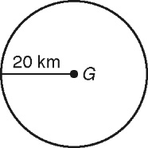 5. 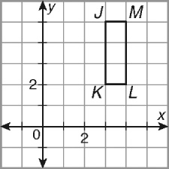

The radius of  is multiplied by  The length and width of a rectangle with   
 vertices J(3, 5), K(3, 2), L(4, 2), and   
 M(4, 5) are both multiplied by 8.

6. A square has a side length of 2 mm. The sides are doubled in length.

7. Describe the effect on the volume of multiplying the length, width, and height of a rectangular

prism by 2.

8. The volume of a rectangular prism is divided by 343 without changing the ratios among the

length, width, and height. Describe the effect of the volume change on each dimension.