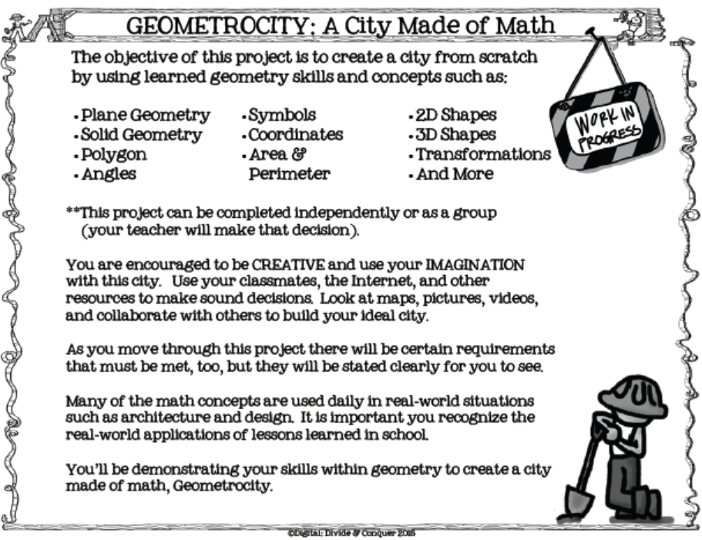
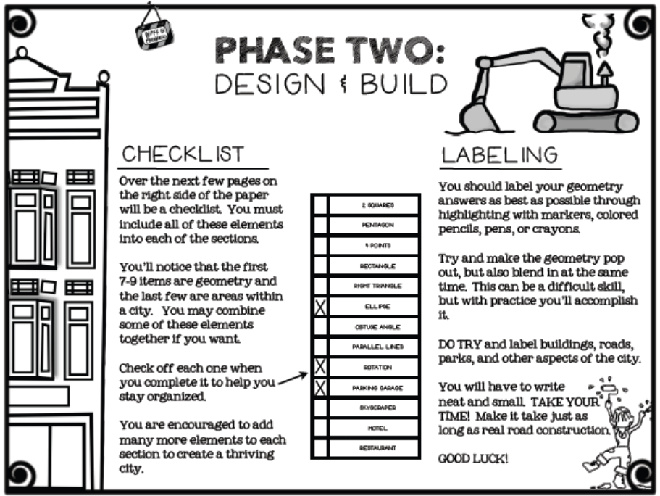
Phase One:
Design

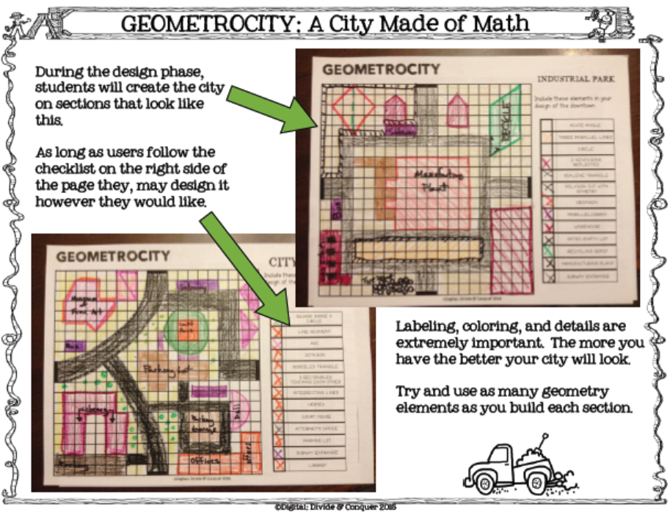
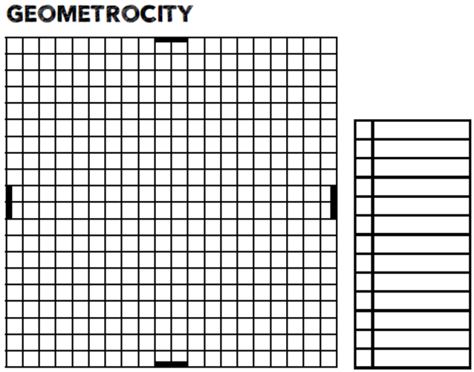
Downtown
Include and clearly mark these elements in your design of downtown.

30°- 60°- 90° triangle

45°- 45°- 90° triangle

Regular hexagon

Square

Isosceles trapezoid

Perpendicular lines

Parallel lines

Parking garage

Skyscraper

Hotel

Restaurant

Department store

Court house
Suburbs
Include and clearly mark these elements in your design of the suburbs.

Rhombus

Cone

Prism

Pyramid

Line segment

Point

Congruent rectangles

Church

School

Gas station

Convenience store

Fast food restaurant

Park
PUBLIC WORKS

Include and clearly mark these elements in your design of public works.

Similar triangles

Intersecting lines

Obtuse angle

Cube

Rectangular prism

Cylinder

Square pyramid

Police station

Fire station

Post office

Laundromat

Dry cleaners

Hospital
ENTERTAINMENT

Include and clearly mark these elements in your design of entertainment.

Kite

Circle

Arc

Vertex

Equilateral triangle

Regular polygon

Octagon

Stadium

Museum

Sports arena

Zoo

Aquarium

Pond

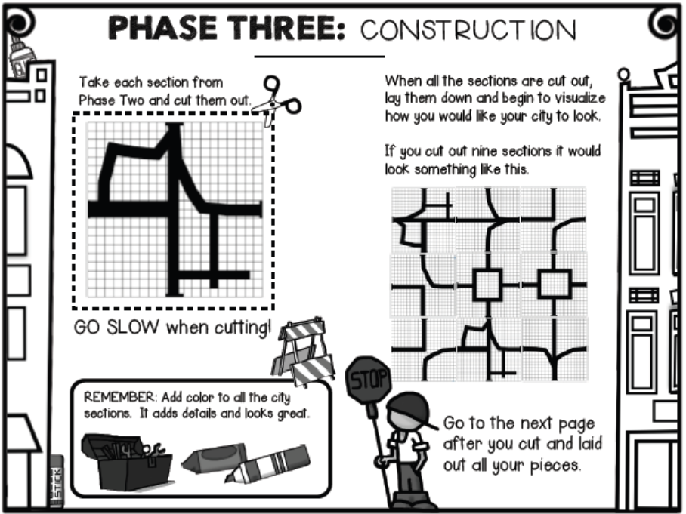
Phase Two: Layout

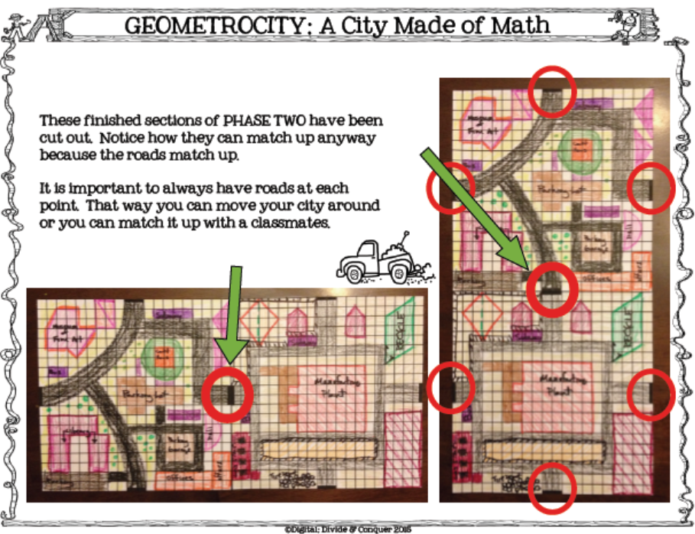
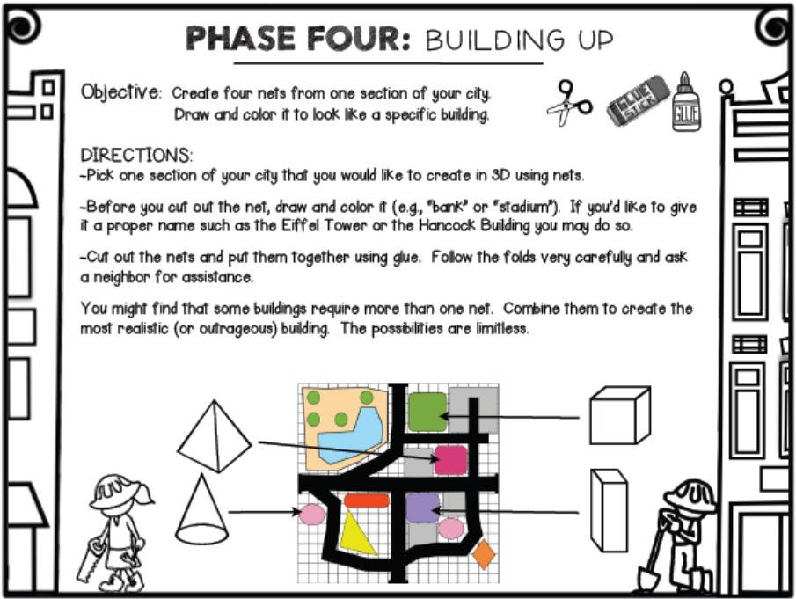
DIRECTIONS:

- Pick sections of your city that you would like to create in 3D nets.

- Before you cut out each net, draw and color it. Give each building a proper name (e.g., “bank” or “stadium”).

- On a separate sheet of paper, list the lateral area, surface area, and volume of each building. Put your measurements in centimeters, rounding to the nearest tenth. Use the name (and shape if using multiple nets) of the building to list its dimensions.

- Cut out the nets and put each together using glue. Follow the folds very carefully and ask for assistance if you need it.

- Combine nets as you wish to create more realistic (or outrageous) buildings.

Phase Three: Building up
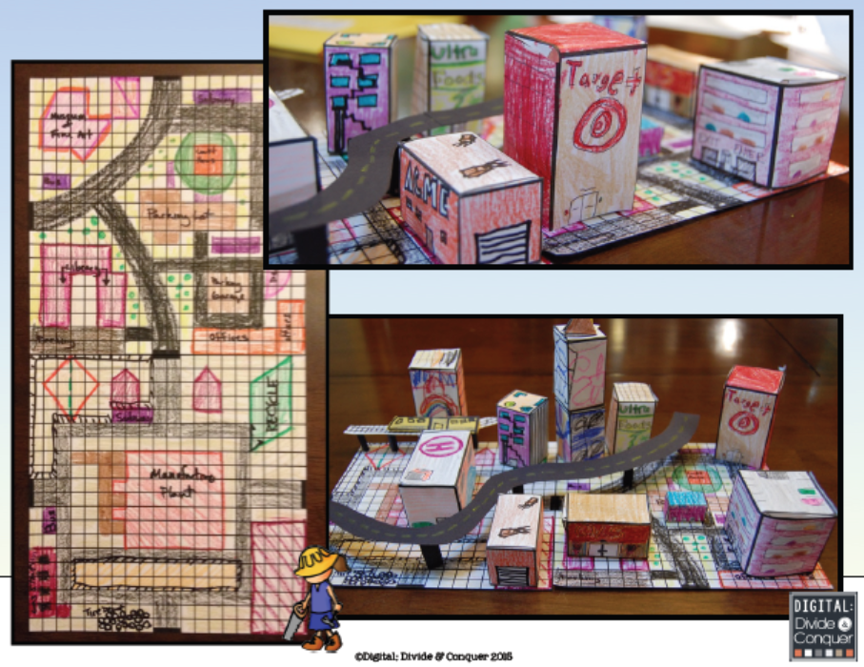
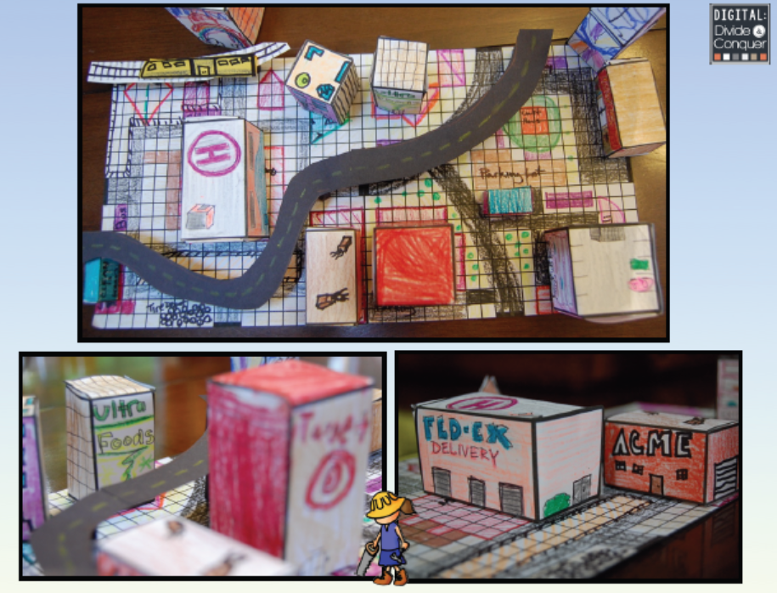
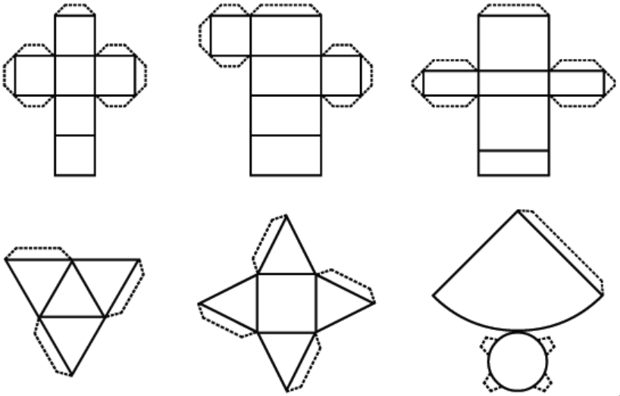

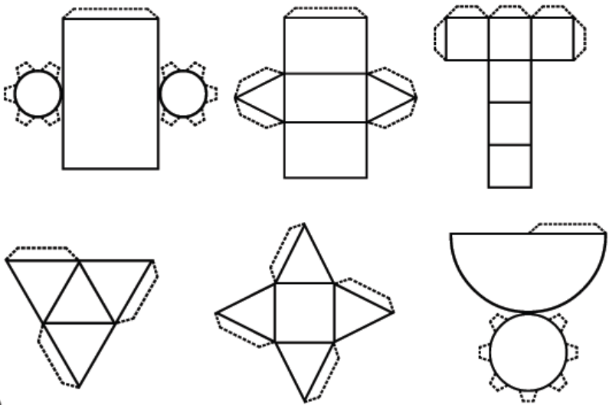

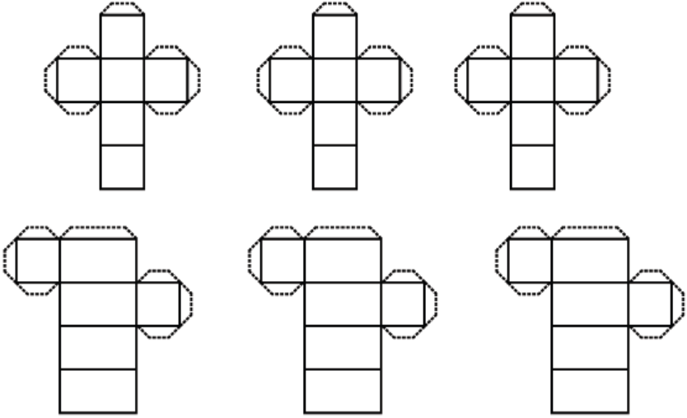

GRADING RUBRIC
Category | 30 points | 26 points | 22 points | 18 points
Phase One: Design | Students create the four sections, including all the elements required. Thought has been put into which elements would most likely be near one another, which would need parking, etc. Sections are neatly done and colored appropriately. | Students create the four sections, including most of the elements required. Thought has been put into which elements would most likely be near one another, but needed parking, etc., may be missing. Sections are neatly done and colored. | Students create the four sections, including most of the elements required. The buildings appear randomly placed, and needed parking space, etc. may be missing. Sections are mostly neat, and some color has been used. | Students have thought about the four sections, and have included some of the elements required. An attempt has been shown at neatness and the addition of color.
Phase Two: Layout | The sections have been neatly cut out and placed in a large square. The roads match up, and buildings that appear next to each other are realistic. The sections have either been taped together, or glued to another surface. All elements requested are present. | The sections have been neatly cut out and placed in a large square. The roads match up, but buildings that appear next to each other may not be realistic. The sections have either been taped together, or glued to another surface. Some required elements are missing. | The sections have been cut out, and placed so that the roads meet. Buildings that appear next to each other may not be realistic. The sections have been taped together so that the roads meet, but a large square is not the shape formed. Some required elements are missing. | The sections have been cut out, but the roads don't always meet, creating no roadway through the entire project. The sections may or may not be glued together to form a large square. Some required elements are missing.
Phase Three: Building Up | Buildings are colored and labeled. Cutting and pasting are neatly done, and some buildings include multiple nets. Students have added something unique, which may be a building, statue, raised roadway, etc. Project is neatly put together, and list of lateral area, surface area, and volume, including calculations, is present and correct. | Buildings are colored and labeled. Cutting and pasting are done, but multiple nets may not have been used for any building. Project is neatly put together, and list of lateral area, surface area, and volume, including calculations, is present and mostly correct. | Buildings are mostly colored and labeled. Cutting and pasting are done, but multiple nets may not have been used for any building. Project is put together, but list of lateral area, surface area, and volume, including calculations, is incomplete. | Buildings are mostly colored and labeled. Project is incomplete, and list of lateral area, surface area, and volume is missing.

+ 5 points – student passes the district semester exam before curve
+ 5 more points – student earns advanced on district semester exam

