Name _____________________________________________________ Date ___________________ Period __________

Geometry Final Review

1. G.2C Given the line, y = -2x + 5, determine the equation of the line parallel to the given line that passes through the point (-3, -4). Represent the line in slope-intercept and standard forms.

2. G.2C Given a line with a slope m = -2 and y-intercept (0, 5), determine the equation of the line perpendicular to the given line that passes through the point (-6, -4). Represent the line in slope-intercept and standard forms.

3. G.2C Given a graph, determine the equation of the line parallel to line AB that passes through the point (-3, -4). Represent the line in slope-intercept and standard forms.
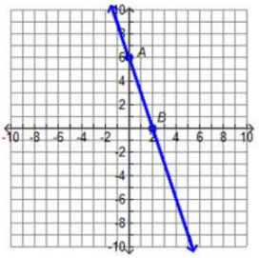

4. G.2C Given a line that passes through the points (1, 3) and (3, -3), determine the equation of the line perpendicular to the given line that passes through the point (-3, -4). Represent the line in slope-intercept and standard forms.

5. G.3A Perform a rigid transformation that translates the image 12 units to the left and 5 units down on the graph below. Complete the following: (x, y) $→$ (__________, __________)
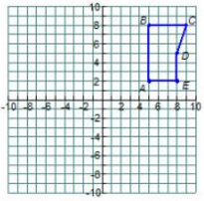

6. G.3A Perform a non-rigid transformation that preserves similarity and dilates the image by a scale factor of k = ½ with the origin at the center of the dilation. Complete the following: (x, y) $→$ (_____, _____)

7. G.4C Prove the following statement is false by providing a counterexample. “If all points are equidistant from the center point of the figure, then the figure is a circle.”

8. G.5A Find the sum of the interior angles of a pentagon.

9. G.5A Find the number of sides of a polygon if the sum of the interior angles is 720°.

10. G.5A Find the measure of each interior angle of a regular decagon.

11. G.6A
1
2
4
3
5
6
7
8

Name the angle pairs and circle if they are congruent or supplementary.
∠1 & ∠2 ____________________________________
congruent supplementary
Name the angle pairs and circle if they are congruent or supplementary.
∠1 & ∠4 ____________________________________
congruent supplementary
Name the angle pairs and circle if they are congruent or supplementary.
∠1 & ∠5 ____________________________________
congruent supplementary
Name the angle pairs and circle if they are congruent or supplementary.
∠1 & ∠7 ____________________________________
congruent supplementary
Name the angle pairs and circle if they are congruent or supplementary.
∠1 & ∠8 ____________________________________
congruent supplementary
Name the angle pairs and circle if they are congruent or supplementary.
∠3 & ∠5 ____________________________________
congruent supplementary
Name the angle pairs and circle if they are congruent or supplementary.
∠3 & ∠6 ____________________________________
congruent supplementary

12. G.6A Give an example of the transitive property.

13. G. 6B State if the two triangles are congruent. If so, tell how.
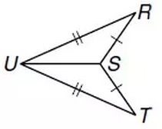
14. G. 6B State if the two triangles are congruent. If so, tell how.
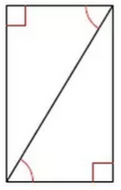

15. G. 6B State if the two triangles are congruent. If so, tell how.
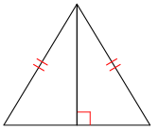

16. G.6D Karlyn is designing a mobile using triangular shapes. He knows the triangle will balance if he can attach the hanger to the center of the mobile. So, in order for the triangle mobile to hang horizontal to the floor, Karlyn needs to find the center. Explain to Karlyn how he might find the center of the triangle.
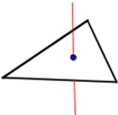

17. G.6D Describe, in words or equations, how the diagram below proves the Pythagorean Theorem.
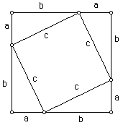

18. G.2B Use the Pythagorean Theorem and the distance formula to prove the length of line d below. Show your work, and leave your answer as a reduced radical.
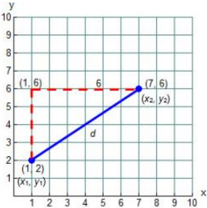

19. G.2B Use the slope formula to find the slope of line d in the graph for number 18. Show your work.

20. G.2B Use the midpoint formula to find the midpoint of line d in the graph for number 18. Show your work.

21. G.3B Using the point (-6, 10) as the center of dilation, dilate the figure ABCD by a scale factor of one-half, then dilate A’B’C’D’ by a scale factor of four using the same center of dilation.
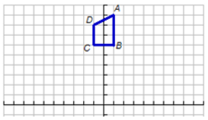

22. G.7A Use the properties of corresponding parts of similar figures to determine if the two figures are similar.

9 in
80° 1 in
100°

6 in 4 in 2 in

12 in 80°
3 in
100°

3 in
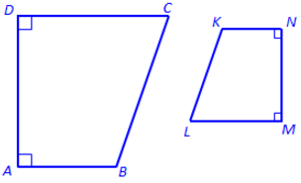

23. G.7B Given ∠B and ∠E are right angles and ∠C and ∠F each measure 32°, verify $∆$ABC$\sim ∆$DEF.
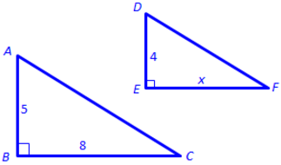

24. G.9A Toan is a building engineer. He is designing a wheelchair ramp for the library. The entrance to the building is 3 feet from the ground. The angle of elevation for the ramp should be 4° to provide easy access to the building. How far from the building will the ramp begin? What is the length of the ramp? Round final answers to the nearest tenth.

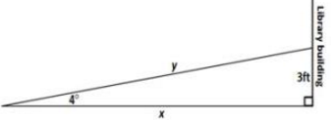
25. G.9B Andres has been hired to walk and check the fence line of a square field with fenced sides of 525 feet. The field also has a fence down the diagonal to separate it into two equal areas. How many feet will Andres have to walk when checking the field if he walks straight paths down all fence lines and does not retrace his steps? Use special right triangles to solve (not the Pythagorean Theorem), and leave your answer in simplified radical form.
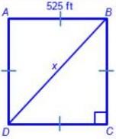

26. G.10B Joshua designs the packages for a candy product. He wants to offer customers different size containers of the candy. Joshua decides to double the volume of the original container, so on his sketch of the container he doubles the radius. Will this result in a container with double the volume of the original? Justify your answer.
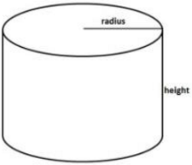

27. G10B What would happen to the volume of the original container for problem 26 if Joshua doubled the height? What would happen to the lateral surface area? Justify your answer.

28. G.11A Find the area of the regular polygon shown below. Round your final answer to the nearest whole number.
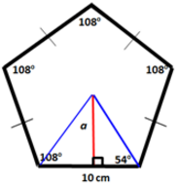

29. G.11A Strickland Construction is building a new office building. The foyer of the building will be laid with solid grey tiles. In the center of the foyer, decorative tiles will be laid to form a regular hexagon with a perimeter of 216 inches. To the nearest hundredth, how many square meters will the hexagon occupy? Show your work. (1 inch = 2.54 centimeters)

30. G.11B The composite figure below represents a blueprint for a flower garden. Flowers will be planted in the shaded region. Find the area in square centimeters, rounding to the nearest tenth if necessary. Each square on the graph represents one square meter.

31. G.11C In North America, the ancient people often buried their dead in mounds shaped like a square pyramid with the top cut off parallel to the base. This shape is called a frustum. For the burial mound below, find the surface area in square feet and square meters that would be exposed to the elements and deteriorate. Round to the nearest tenth, where appropriate. (3.28 feet = 1 meter)
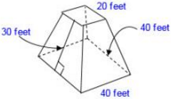

32. G.11C Find the lateral and total surface area of the given square pyramid. The slant height is 20 feet and the altitude is 16 feet.
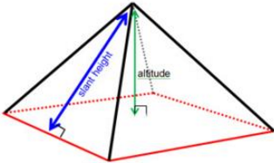

33. G.11D A three-dimensional figure is formed by placing a right cylindrical hole through a rectangular prism as shown below. Determine the volume of the figure rounded to the nearest whole number.
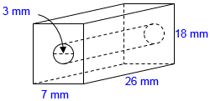

34. G.11D A three-dimensional figure is formed by placing a square pyramid on top of a prism as shown below. Determine the volume in cubic inches of the three-dimensional figure. (2.54 cm = 1 in)
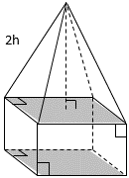
5 cm
3 cm
6 cm

35. G.13A The list below represents six athletes running in the 100-meter dash with the numbers they will be wearing on their jerseys. How many ways can gold, silver, or bronze medals be awarded to the athletes in the 100-meter dash.
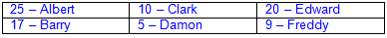

36. G.13A The cafeteria has six different canned fruits from which to make fruit salad for lunch. They will only be using three of the canned fruits in the salad. How many outcomes are possible for a three-fruit fruit salad?

37. G.13A What is the probability that a seven-digit telephone number generated using the digits 1, 2, 3, 1, 2, 4, and 3 is the number 123-1243?

38. G.13B At a school fair students were challenged to hit one of the small, congruent, equilateral triangular regions on the large, equilateral triangular board below with a dart. If the dart thrown hits the large triangular board, what is the probability that it hits one of the shaded regions?
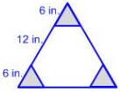

39. G.13B Herbert threw a dart at random onto the circular board shown below. Assuming he hits the board, what is the probability he hits the shaded region?
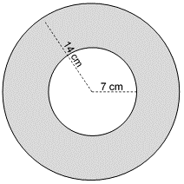

40. G.13B Bridget and Sarah are playing a game. They have two containers. One container has 2 red, 1 yellow, and 1 blue marble. The other container has 1 red, 1 yellow, and 1 blue cube. Points are earned by drawing the same color from each container. Use the area model below to determine the probability of choosing the same color from each container.
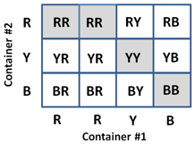

41. G.13C What is the probability of throwing two dice and getting a 3 on both?

42. G.13C Five sandwiches are in a box on the table: 1 tuna, 2 chicken salad, 1 ham, and 1 turkey. Five people need a sandwich. The sandwiches are wrapped, and the type of sandwich cannot be determined by looking at the wrapper. Given that Rodolfo chooses first, and Terry choses second, what is the probability that both choose chicken salad?

Tori has a bag of colored marbles. Five marbles are red, four are green, ten are blue, and one is white. Marbles are randomly selected from the bag. Use this information for numbers 42 and 43 below.

42. G.13C What is the probability of choosing a green marble and then a blue marble, with replacement? Is this an example of independent or dependent compound events?

42. G.13C What is the probability of drawing a red marble and then a white marble, without replacement? Is this an example of independent or dependent compound events?

43. G.13D At SGP9, 16% of all students play football and basketball, and 24% of all students play football. What is the probability that a student plays basketball, given that the student plays football?

44. G.13E A game requires rolling a six-sided die and spinning a spinner. The spinner has four equal sections (red, blue, green, and yellow).
a. Determine the conditional probability of P(blue│6).

b. Are the events independent or dependent?

45. G.13E A box of four crayons contains 1 red crayon, 1 blue crayon, 1 green crayon, and 1 yellow crayon. From the box, Renan randomly selects a crayon, then (without replacement) selects another.
a. Determine the conditional probability of P(blue│red).

b. Are the events independent or dependent?

46. G.13E A jar contains 3 red, 2 blue, and 5 green gumballs. Dallis randomly selects one gumball, then (without replacement) selects another. What is the probability of selecting two green gumballs in a row? Express the probability as a fraction, a decimal, and a percent.

