Dimensional Change – Change in Length, Width, and/or Height

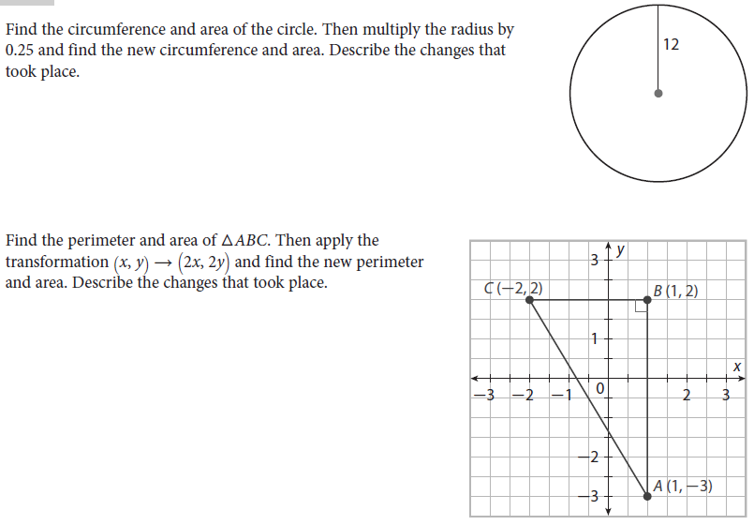
2.
1.
3. The volume of a rectangular prism can be found with the formula V = lwh, where V is volume, l is length, w is
width, and h is height. Surface area can be calculated using the formula S = 2(wl + hl + hw).
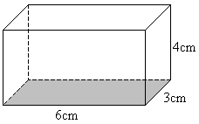
a. Find the volume of the prism. Find its surface area.

b. Find the volume of the prism if the length of 6cm is multiplied by 5.

c. Find the volume of the prism if the length of 6cm and the width of 3cm are both multiplied by 5.

d. Find the volume of the prism if the length, width, and height are multiplied by 5. Find its surface area.

e. Describe your findings about volume from a, b, c, and d. Describe your findings about surface area from
a and d.

