Name ____________________________________________________ Date _______________ Period _______

Experimental and Theoretical Probability Practice

- A baseball player got a hit 19 times in his last 64 times at bat.
- What is the experimental probability that the player gets a hit in an at bat?

- If the player comes up to bat 200 times in a season, about how many hits is he likely to get?

- A medical study tests a new cough medicine on 4250 people. It is effective for 3982 people. What is the experimental probability that the medicine is effective? For a group of 9000 people, predict the approximate number of people for whom the medicine will be effective.

A bag contains letter tiles that spell the name of the state MISSISSIPPI. Find the theoretical probability of
drawing one tile at random for each of the following.
- P(M) 4. P(I) 5. P(S) 6. P(P)

- P(not M) 8. P(not I) 9. P(not S) 10. P(not P)

11. A music collection includes 10 rock CDs, 8 country CDs, 5 classical CDs, and 7 hip hop CDs.
a. What is the probability that a CD randomly selected from the collection is a classical CD?

- What is the probability that a CD randomly selected from the collection is not a classical CD?

12. You are playing a board game with a standard number cube. It is your last turn and if you roll a number
greater than 2, you will win the game. What is the probability that you will not win the game?

13. If there is a 70% chance of snow this weekend, what is the probability that it will not snow?

14. From 15,000 graphing calculators produced by a manufacturer, and inspector selects a random sample of 450 calculators and finds 4 defective calculators. Estimate the total number of defective calculators out of the 15,000.

A student randomly selected 65 vehicles in the student parking lot and noted the color of each. She found
that 9 were black, 10 were blue, 13 were brown, 7 were green, 12 were red, and 14 were a variety of other
colors. What is each experimental probability?
15. P(red) 16. P(black)

17. P(not blue) 18. P(not green)
19. Genetics was first studied by Gregor Mendel, who experimented with pea plants. He crossed pea plants that had yellow, round seeds with pea plants that had green, wrinkled seeds. The following are the probabilities for each type of new seed.
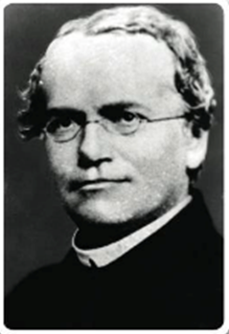

yellow, round: 56.25% green, round: 18.75%
yellow, wrinkled: 18.75% green, wrinkled: 6.25%

If 2014 seeds were produced, how many of each variety would you expect?

For exercises 20-23, describe each situation using one of the following probabilities. Explain your answer.

I. 0 II. between 0 and 0.5 III. between 0.5 and 1 IV. 1

20. having school on Tuesday
21. two elephants in the city zoo having the same weight
22. getting your driver’s license at the age of 10
23. turning on the TV while a commercial is playing

24. The students in a math class took turns rolling a standard number cube.
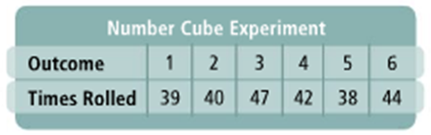
The results are shown in the table at the right.

- What is the theoretical probability of rolling the
number 1 with the number cube?

- What was the experimental probability of rolling
the number 1 for the experiment in class?

25. Another way to express probability is with odds. Odds compare the number of favorable outcomes to the
number of unfavorable outcomes. Odds in favor of an event are usually written as

number of favorable outcomes: number of unfavorable outcomes.

Suppose the probability of drawing a red marble from a bag of marbles is $\frac{3}{10}$. What are the odds in favor of
drawing a red marble?

