13-2 Practice
Probability with Permutations and Combinations
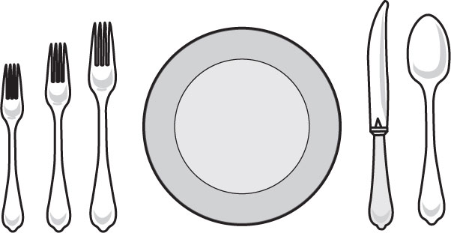
1. FORMAL DINING You are handed 5 pieces of silverware for the formal setting shown. If you guess their placement at random, what is the probability that the knife and spoon are placed correctly?

DAY 1 STANDINGS
MCAFEE,DAVID | –3
FORD, GABE | –2
STANDISH,TRISTAN | –2
NOCHOLS,WYATT | –1
PURCELL,JACK | –1
ANDERSON,BILL | –1
WRIGHT, ISAAC | –1
FILBERT,MITCH | +1
2. GOLF The standings list after the first day of a 3-day tournament is shown below. What is the probability that Wyatt, Gabe, and Isaac will all finish in the top 3?

3. PHONE NUMBER What is the probability that a phone number generated using the digits 1, 2, 2, 4, 5, 5, 6, and 2 is the number 654-5222?

4. LETTERS Jaclyn bought some decorative letters for a scrapbook project.
If she selected a permutation of the letters shown, what is the probability that they would form the word “photography”?

5. COFFEE BREAK A group of 6 friends of varying ages meets at a coffee shop and sits in a circle. What is the probability that the youngest member of the group sits in the seat closest to the door?

6. JEWELRY Bonita bought her mom a charm bracelet. Each charm is labeled with a one-word message.
What is the probability that the 5 charms were hung in the order: dream, believe, love, laugh, inspire?

7. COLLEGES Mark wants to visit the 10 colleges he is considering attending. He can only spend the night at 3 of them. What is the probability that he spends a night at Rutgers University, a night at the University of Miami, and a night at Clemson University?

8. ODD JOBS Matthew put fliers advertising his lawn service on the doors of 20 families’ houses in his neighborhood. If 6 families called him, what is the probability that they were the Thompsons, the Rodriguezes, the Jacksons, the Williamses, the Kryceks, and the Carpenters?

