Regular Polygons and Angle Relationships

A ________________ polygon is a special polygon which is both equilateral and equiangular. Suppose each of the polygons below is a ________________ polygon, and is divided into triangular regions as shown.
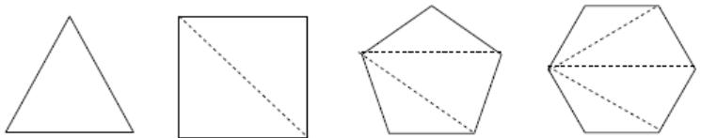
What is the interior angle sum for the triangle? What theorem justifies this conjecture?

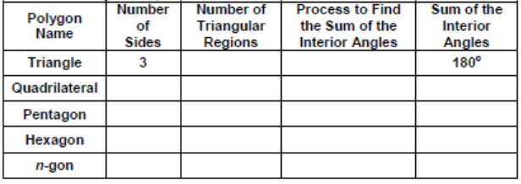

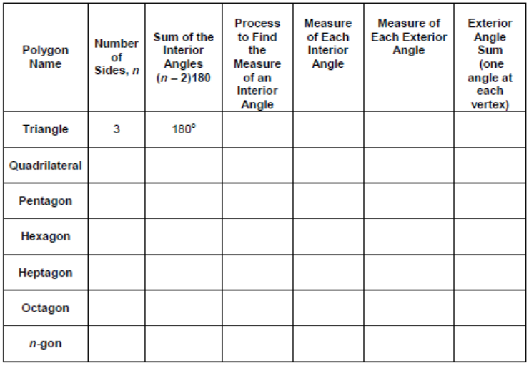
Regular Polygons and Angle Relationships

A ________________ polygon is a special polygon which is both equilateral and equiangular. Suppose each of the polygons below is a ________________ polygon, and is divided into triangular regions as shown.
What is the interior angle sum for the triangle? What theorem justifies this conjecture?

