Rhombi and Squares Practice

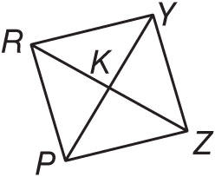
PRYZ is a rhombus. If RK = 5, RY = 13 and m∠YRZ = 67, find each measure.

1. KY 4. m∠PRZ

2. PK 5. m∠RPZ

3. m∠YKZ

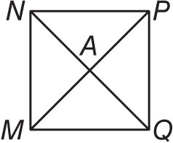
MNPQ is a rhombus. If PQ = 3$\sqrt{2}$ and AP = 3, find each measure.

6. AQ 8. m∠MNP

7. m∠APQ 9. PM

COORDINATE GEOMETRY Given each set of vertices, determine whether BEFG is a rhombus, a rectangle, or a square. List all that apply. Explain.

10. B(–9, 1), E(2, 3), F(12, –2), G(1, –4)

11. B(1, 3), E(7, –3), F(1, –9), G(–5, –3)

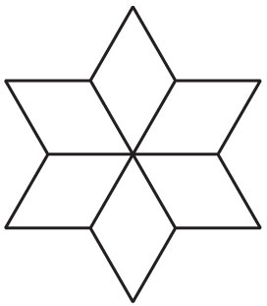
12. TESSELLATIONS The figure is an example of a tessellation. Use a ruler or protractor
to measure the shapes and then name the quadrilaterals used to form the figure.

13. WINDOWS The edges of a window are drawn in the coordinate plane.
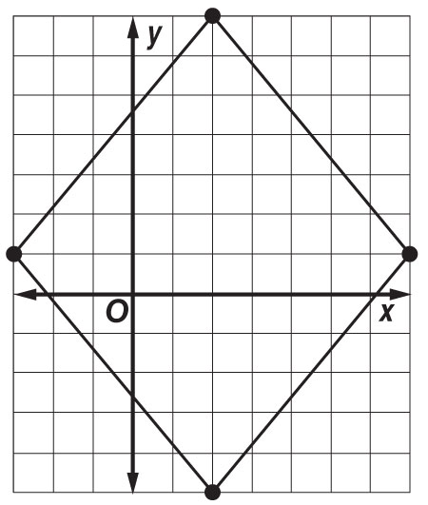

Determine whether the window is a square or a rhombus.

