Name __________________________________________________________________ Date ______________________________ Period _____________

Unit 7 Review
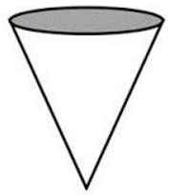

- Name the shape of a vertical
cross section of a cone.

_______________________

- For kite WXYZ, find m∠Z.
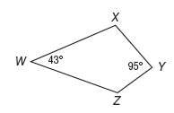

- Determine whether the quadrilateral is a parallelogram. Justify your answer.
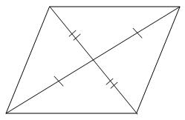

- Find the values of x and y that prove the quadrilateral is a parallelogram.
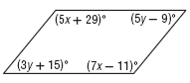
A x = 20; y = 12
B x = 168; y = 12
C x = 129; y = 51
D x = 20; y = 160

- In rhombus LMNP, if LM = 7, find NP.
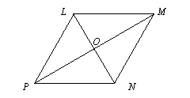
- In isosceles trapezoid FIZP, if IC = 7.9 and FZ = 14.3, find CP.
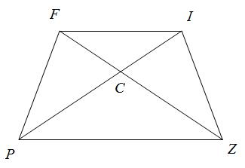

- The measure of each interior angle of a regular polygon is 172. Find the number of sides in the polygon. Show all work.

Use the diagram below to answer questions 8 and 9. Show all work.
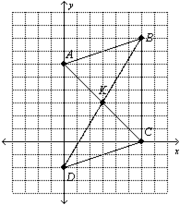
- What is the length of segment AK?

- Show that ABCD is a parallelogram using the properties of a parallelogram.

- Find the measure of each interior angle for a regular heptagon. Round to the nearest tenth if necessary. Show all work.

- Given P(-5, -8), Q(4, -8), R(4, 1), and S(-5, 1), determine if the quadrilateral is a rhombus, rectangle, or square. List all that apply, and explain your reasoning.

- Find the measure of an exterior angle of a regular polygon with 16 sides. Round to the nearest tenth if necessary. Show all work.

- Find the measure of each exterior angle for a regular triangle. Round to the nearest tenth if necessary.

- Find the measure of each interior angle of a nonagon in which the measure of the interior angles are 3x +15, 2x + 30, 3x + 10, 2x + 55, 2x + 60, 2x – 35, 3x – 5, x + 40, and 2x + 70. Show all work.

For questions 15 and 16, use the rectangle below. Show all work.
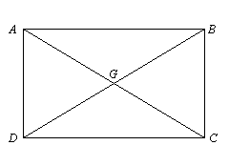
- If AG = 8s + 39 and DG= -3s + 72, find BD.

- If m∠ADB = 6m + 91 and m∠CDB = -4m + 17, find m∠CBD.

- Name the shape resulting from the cross-section of the triangular prism shown below.
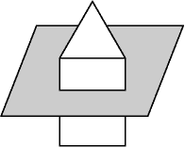

- The measure of each exterior angle of a regular polygon is 18. Find the number of sides in the polygon. Show all work.

Name the cross section created in each of the drawings below.

19.

20.
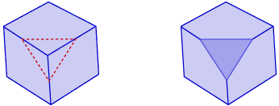

21.
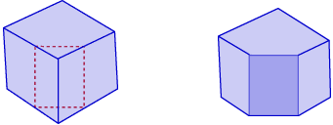

22.
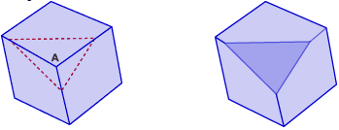

23.
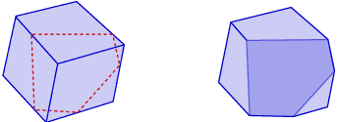

24.
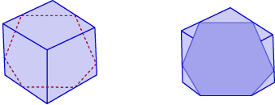

25.
