TRAPEZOIDS

A trapezoid is a _______________________ with exactly ______ pair of parallel sides.

BASES:______________________________________________

LEGS: _______________________________________________

BASE ANGLE: ________________________________________
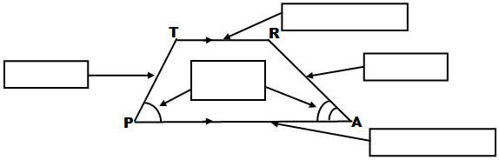
ISOSCELES TRAPEZOID: ______________________________

_____________________________________________________

MIDSEGMENT OF A TRAPEZOID (MEDIAN): _______________

_____________________________________________________

_____________________________________________________

_____________________________________________________
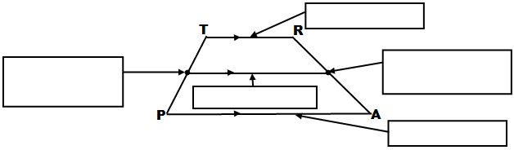
MIDSEGMENT = ____________________

To summarize, what can be said of all trapezoids?

In addition, what can we say about isosceles trapezoids?

TRAPEZOIDS

A trapezoid is a _______________________ with exactly ______ pair of parallel sides.

BASES:______________________________________________

LEGS: _______________________________________________

BASE ANGLE: ________________________________________
ISOSCELES TRAPEZOID: ______________________________

_____________________________________________________

MIDSEGMENT OF A TRAPEZOID (MEDIAN): _______________

_____________________________________________________

_____________________________________________________

_____________________________________________________
MIDSEGMENT = ____________________

To summarize, what can be said of all trapezoids?

In addition, what can we say about isosceles trapezoids?

