Rectangles Practice

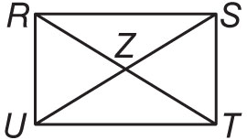
ALGEBRA Quadrilateral RSTU is a rectangle.
1. If UZ = x + 21 and ZS = 3x – 15, find US.

2. If RZ = 3x + 8 and ZS = 6x – 28, find UZ.

3. If RT = 5x + 8 and RZ = 4x + 1, find ZT.

4. If m∠SUT = 3x + 6 and m∠RUS = 5x – 4, find m∠SUT.

5. If m∠SRT = x + 9 and m∠UTR = 2x – 44, find m∠UTR.

6. If m∠RSU = x + 41 and m∠TUS = 3x + 9, find m∠RSU.

Quadrilateral GHJK is a rectangle. Find each measure if m∠1 = 37.
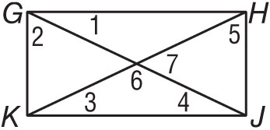
7. m∠2 8. m∠3

9. m∠4 10. m∠5

11. m∠6 12. m∠7
Determine whether the figure is a rectangle. Justify your answer using the indicated formula.

13. B(–4, 3), G(–2, 4), H(1, –2), L(–1, –3); Slope Formula

14. N(–4, 5), O(6, 0), P(3, –6), Q(–7, –1); Distance Formula

15. Huntington Park officials approved a rectangular plot of land for a Japanese Zen garden. Is it sufficient to know that opposite sides of the garden plot are congruent and parallel to determine that the garden plot is rectangular? Explain.

16. A landscaper is marking off the corners of a rectangular plot of land. Three of the corners are A(0, 6), B(5, -4), and C(-1, -7). What are the coordinates of the fourth corner?

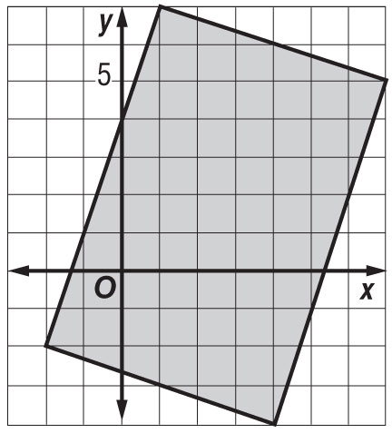
17. Antonio is designing a swimming pool on a coordinate grid. Is it a rectangle? Explain.

